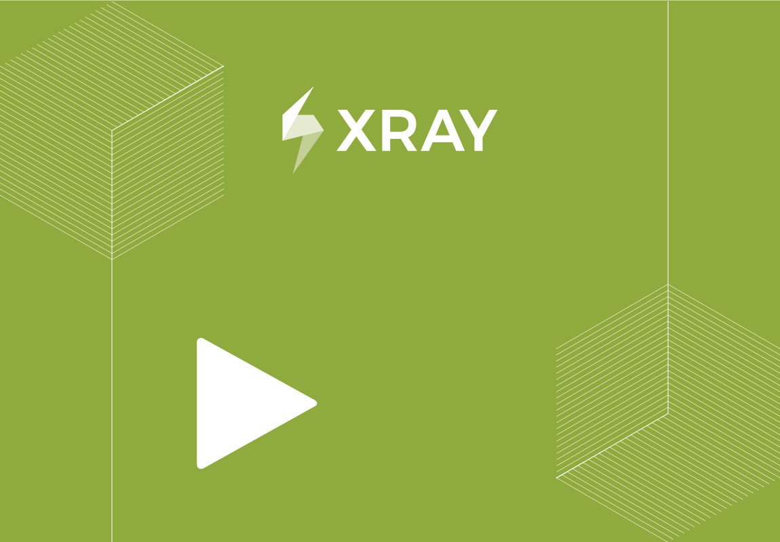

Project Name: MRAPB2

Issue: MRPB2-841

Prepared By:

Document Date: 7/12/2023

CONFIDENTIAL


TEST EXECUTION
Test Execution for Test Plan MRPB2-840

TABLE OF CONTENTS

1. Introduction 3
1.1. Document Overview 3
1.2. Test Execution MRPB2-841 Details 3
1.3. Requirements covered by this Test Execution 3
1.4. Overall Execution Status 3
1.5. Defects 4
1.6. Test Runs 4
2. Test Run Details 4
2.1. MRAPB2 / Test Execution: MRPB2-841 / Test: MRPB2-675 - this is a test 4
2.1.1. Execution Defects 4
2.1.2. Execution Evidences 4
2.1.3. Comment 5
2.1.4. Test Description 5
2.1.5. Test Issue Attachments 5
2.1.6. Test Details 6
2.1.7. Requirements linked with this test 6
2.2. MRAPB2 / Test Execution: MRPB2-841 / Test: MRPB2-736 - LOIC_INTRO 6
2.2.1. Execution Defects 6
2.2.2. Execution Evidences 6
2.2.3. Comment 6
2.2.4. Test Description 6
2.2.5. Test Issue Attachments 6
2.2.6. Test Details 7
2.2.7. Requirements linked with this test 7
2.3. MRAPB2 / Test Execution: MRPB2-841 / Test: MRPB2-735 - ELO_CONSULT 7
2.3.1. Execution Defects 7
2.3.2. Execution Evidences 7
2.3.3. Comment 7
2.3.4. Test Description 7
2.3.5. Test Issue Attachments 7
2.3.6. Test Details 8
2.3.7. Requirements linked with this test 8
3. Appendix A: Approval 11

Introduction

Document Overview
This Test Report provides a summary of a test execution. This document has been generated automatically from the test management platform.

Test Execution MRPB2-841 Details

Description | None
Begin Date
End Date
Revision | None
Test Environments
Test Plan | MRPB2-840 - gvcnb

Requirements covered by this Test Execution

Key | Summary | Workflow Status

Overall Execution Status
Of the 3 Test Runs contained on MRPB2-841:
Status | #TestRuns | Percentage
TODO  EXECUTING  PASS  FAIL  ABORTED | 0  0  0  0  0 | 0 %  0 %  0 %  0 %  0 %

Defects
Key |  | Summary | Priority
MRPB2-843 | def1 |  |  | Medium
MRPB2-844 | this is a test bug |  |  | Medium

Test Runs
Key | Summary | Test Type | #Req | #Def | Test Sets | Assignee | Status
MRPB2-675 | this is a test |  |  | 1 |  |  | TO DO
MRPB2-736 | LOIC_INTRO |  |  | 0 |  |  | TO DO
MRPB2-735 | ELO_CONSULT |  |  | 1 |  |  | TO DO

Test Run Details

MRAPB2 / Test Execution: MRPB2-841 / Test: MRPB2-675 - this is a test
Execution Status | Assignee | Executed By | Started On | Finished On | Versions | Revision
TO DO

Execution Defects
Key | Summary | Priority
MRPB2-843 | def1 | Medium

Execution Evidences
There are 0 Execution Evidences on this Test Run.

Comment
None.

Test Description
this is a automation test

Test Issue Attachments
MRPB2-675 has 0 Attachments.

Test Details
Test Type  Gherkin Specification | Cucumber  Given user navigates to Facebook  When I enter correct username and password  Then login should be successful

Requirements linked with this test
None.

MRAPB2 / Test Execution: MRPB2-841 / Test: MRPB2-736 - LOIC_INTRO
Execution Status | Assignee | Executed By | Started On | Finished On | Versions | Revision
TO DO

Execution Defects
There are 0 Execution Defects on this Test Run.

Execution Evidences
There are 0 Execution Evidences on this Test Run.

Comment
None.

Test Description
this is a automation test

Test Issue Attachments
MRPB2-736 has 0 Attachments.

Test Details
Test Type  Specification | Generic  LOIC_SMOKE_TEST.LOIC_INTRO_TREAT.LOIC_INTRO

Requirements linked with this test
None.

MRAPB2 / Test Execution: MRPB2-841 / Test: MRPB2-735 - ELO_CONSULT
Execution Status | Assignee | Executed By | Started On | Finished On | Versions | Revision
TO DO

Execution Defects
Key | Summary | Priority
MRPB2-844 | this is a test bug | Medium

Execution Evidences
There are 0 Execution Evidences on this Test Run.

Comment
None.

Test Description
this is a automation test

Test Issue Attachments
MRPB2-735 has 0 Attachments.

Test Details
Test Type  Specification | Generic  LOIC_SMOKE_TEST.ELO_CONSULT

Requirements linked with this test
None.

Appendix A: Approval
The undersigned acknowledge they have reviewed the Test Execution and agree with the approach it presents. Changes to this Test Execution will be coordinated with and approved by the undersigned or their designated representatives.

Signature: |  | Date:
Print Name:
Title:
Role:

