Key: GNT-234
Description:
This is screenshot
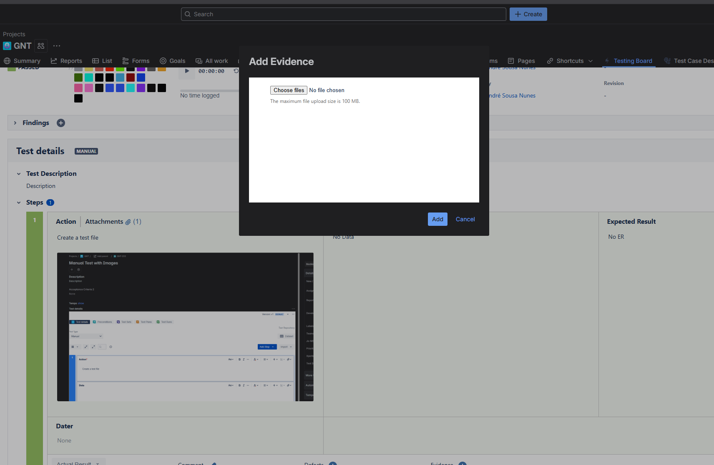
Test Environments:

TO DO: 0% - 0

EXECUTING: 0% - 0

PASSED: 100% - 1

FAILED: 0% - 0

ABORTED: 0% - 0

Number of Tests associated: 1

Key: GNT-233
Test Status: PASSED
// Iterating over test steps for each test
Action: Create a test file
!https://eu.xray.cloud.getxray.app/enterprise/api/internal/attachments/54db67b1-d245-41ff-b46e-d1a156293945?inXray=true|width=1508,height=876!
Data: No Data
Expected Result: No ER

Number of associated test plans: 1
Summary: Test TestPlan

Number of associated test runs: 1
Assignee Id:
Key: GNT-233
Summary: Manual Test with Images
Comment:
Generic Test Definition:
Cucumber Scenario:
Executed by:
Execution Status: PASSED
Started on: 2025-07-30T13:36:58.146Z
Finished on: 2025-07-30T13:36:58.146Z
Test Type: Manual
Test Version Name: v1
Test Version Id: 688a1eea6401ed926a587be7
Test Version Number: 1
Test Version Created: 2025-07-30T14:32:25+01:00
Test Version Updated: 2025-07-30T14:33:20+01:00
Test Version Author:
Test Version Author Id:
Test Version Author Email Address:
Test Version Is Default: true
Test Version Is Archived: false

Execution Evidences Total: 1
Id: 82b3b4b4-d017-4e25-8b94-10f143cb534e
Name: Screenshot_1.png
Size: 92023
Human Readable Size: 92 kB
Created: 2025-09-22T14:00:38+01:00
Mime Type: image/png
File URL: https://sandbox.net/plugins/servlet/ac/com.xblend.plugins.xray-enterprise/attachment?ac.id=82b3b4b4-d017-4e25-8b94-10f143cb534e


Execution Defects Total: 0

Test Steps Total: 1
Action:
Create a test file
Comment:
Data:
No Data
Expected Result:
No ER
Actual Result:
Status: PASSED
Step Number: 1

Test Steps Attachments Count: 1
Id: 54db67b1-d245-41ff-b46e-d1a156293945
Name: image.png
Author:
Created: 2025-09-22T14:00:57+01:00
File URL: https://sandbox.net/plugins/servlet/ac/com.xblend.plugins.xray-enterprise/attachment?ac.id=54db67b1-d245-41ff-b46e-d1a156293945

Test Steps Evidences Count: 1
Id: 9be17da5-3959-42e7-a704-98b07e135cee
Name: Screenshot_1.png
Created: 2025-09-22T13:34:03+01:00
File URL: https:// sandbox.net/plugins/servlet/ac/com.xblend.plugins.xray-enterprise/attachment?ac.id=9be17da5-3959-42e7-a704-98b07e135cee

Test Steps Evidences Count: 0

