OQPQ to verify eQMS-Sign functionality

Project Name: eQMS-Sign

Department: QA

TABLE OF CONTENTS

1. Pre-Execution Approvals (Electronic Signatures) 3
2. Revision History 4
3. Test Objective 4
3.1. Requirements 4
3.2. Test Execution Summary 4
4. Test Assumptions and Prerequisites 5
5. Test Execution Instructions 5
6. Test Execution Details 6
7. Discrepancy Log 90
8. Post-Execution Approvals (Electronic Signatures) 91

- Pre-Execution Approvals (Electronic Signatures)
STATUS: APPROVED

Meaning of Signature | Role |  | Signed By |  | Date
AUTHOR |  | Script Author |  | Hilton Caeiro (HCaeiro) |  | 06-Jun-2025 9:04 AM EDT
REVIEWER |  | Validation Lead |  | Preeti Chauhan (pchauhan) |  | 06-Jun-2025 6:36 PM IST
APPROVER |  | QA Lead |  | Padmanabhan G M (pmuthukrishnan) |  | 06-Jun-2025 6:41 PM IST

- Revision History
Revised overall test script to document that the requirements for eQMS-Sign have been split into two documents "URS eQMS-Sign" and "CS eQMS-Sign".
- Test Objective
This OQPQ test script will verify all the requirements of eQMS-Sign as documented in "URS eQMS-Sign" and "CS eQMS-Sign".

Requirements
All requirements in "URS eQMS-Sign" and "CS eQMS-Sign".

Test Execution Summary
Test Script Name & ID | OQPQ eQMS-Sign Functionality Verification V06 (SIGN-TST-8)
Test Execution Started Date | 09-Jun-2025 03:14 AM EDT
Test Execution Completed Date | 09-Jun-2025 10:03 AM EDT
Overall Test Results | PASS
Execution Approval Status | APPROVED
Test Environment | Production Environment

- Test Assumptions and Prerequisites
- The requirements for eQMS-Sign have been approved.
- The eQMS-Sign application has been configured as per "URS eQMS-Sign" and "CS eQMS-Sign".
- The following accounts will be used for testing:
  - Prudentia QA (Super Admin) - <Admin User>
  - Prudentia UA (Regular User) - <Regular User>
  - Prudentia Tester1 (Contact) - <Contact1>
  - Prudentia Tester2 (Contact) - <Contact2>
- The accounts listed above are available in eQMS-Sign.
- Access eQMS-Sign using Google chrome browser.

- Test Execution Instructions
- All entries made must be clear and legible.
- Provide a reason for any correction.
- The necessary screen shots as indicated in the test steps will be captured as evidence.
- Screen shot must display system Date and Time. When using eQUATe to capture screenshots, do not edit the file name.
- All attachments should be fully identified and cross-referenced to corresponding steps. Please append the step number to the attachment name when uploading to the eQUATe system.
- Tester should add any comments related the test execution in the Tester's Comments section.
- Technical Reviewer should add any comments related the test results review in the Technical Reviewer's Comments section.
- Quality Reviewer should add any comments related the test results review in the Quality Reviewer's Comments section.

- Test Execution Details

Step No. | Step Description |  | Step Data | Expected Results | Pre-Execution Attachments
1 | Confirm that all pre-requisites listed in this test script have been met. |  | NA | Confirmed that all pre-requisites listed in this test script have been met. | NA
Evidence |  | Discrepancy |  | Actual Results | Status
NA |  | NA |  | As expected. | PASS

Step No. | Step Description |  | Step Data | Expected Results | Pre-Execution Attachments
2 | Note the following accounts used for testing in actual results:  - <Admin User>  - <Regular User>  - <Contact1>  - <Contact2>  The document "eQMS-Sign Test Document" attached to this test step will be used for test purposes and will be referred to as <Test Document>. |  | NA | The accounts used for testing are captured in actual results. | eQMS-Sign Test Document.pdf
Evidence |  | Discrepancy |  | Actual Results | Status
NA |  | NA |  | As expected.  <Admin User> : QA@prudentia-grp.com  <Regular User> : UA@prudentia-grp.com  <Contact1> : hcaeiro@prudentia-grp.com  <Contact2> : pchauhan@prudentia-grp.com | PASS

Step No. | Step Description |  | Step Data | Expected Results | Pre-Execution Attachments
3 | Navigate to the eQMS-Sign login screen.  Login using the account <Admin User>.  Take a screenshot. |  | NA | eQMS-Sign home page is displayed.  Screenshot is attached. | NA
Evidence |  | Discrepancy |  | Actual Results | Status
screenshot-1_step#3.png |  | NA |  | As expected. | PASS

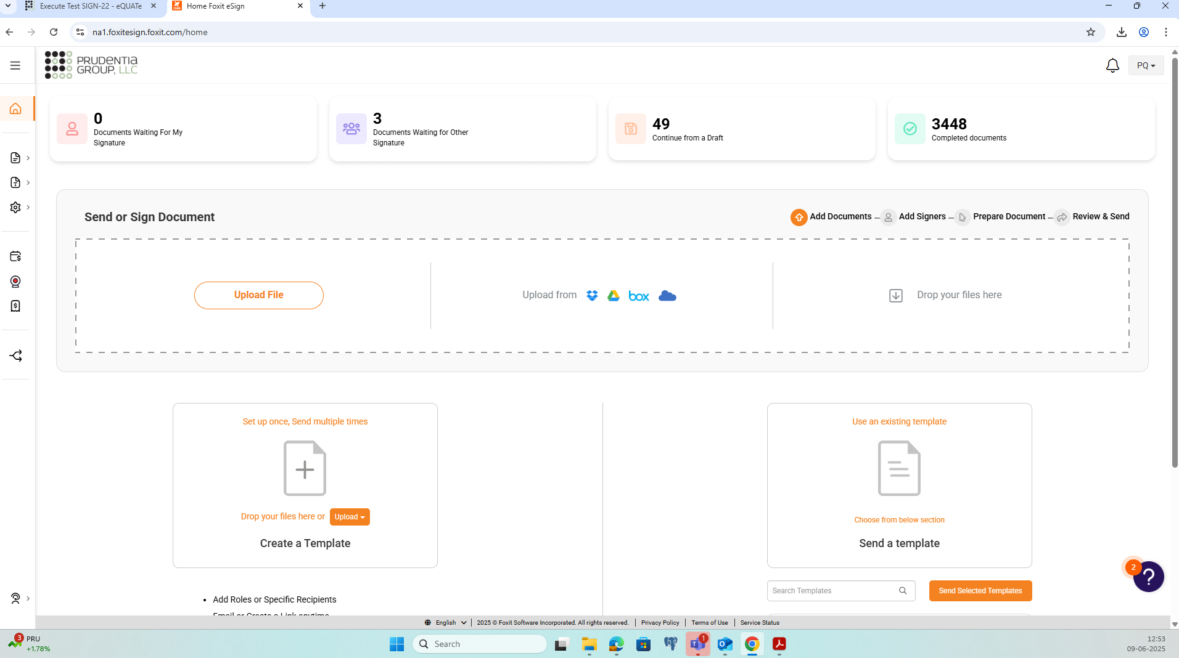

Step No. | Step Description |  | Step Data | Expected Results | Pre-Execution Attachments
4 | Verify that all configurations match those documented in Section 5.1 - Configuration Requirement Specifications in the document "CS eQMS-Sign".  Take screenshots as evidence. |  | NA | Verified all configurations as per "CS eQMS-Sign".  Screenshots attached. | NA
Evidence |  | Discrepancy |  | Actual Results | Status
screenshot-2_Step#4.png  screenshot-3_step#4.png  screenshot-4_Step#4.png  screenshot-5_Step#4.png  screenshot-6_Step#4.png  screenshot-7_Step#4.png  screenshot-8_Step#4.png  screenshot-9_Step#4.png  screenshot-10_Step#4.png  screenshot-11_Step#4.png  screenshot-12_Step#4.png |  | NA |  | As expected. | PASS

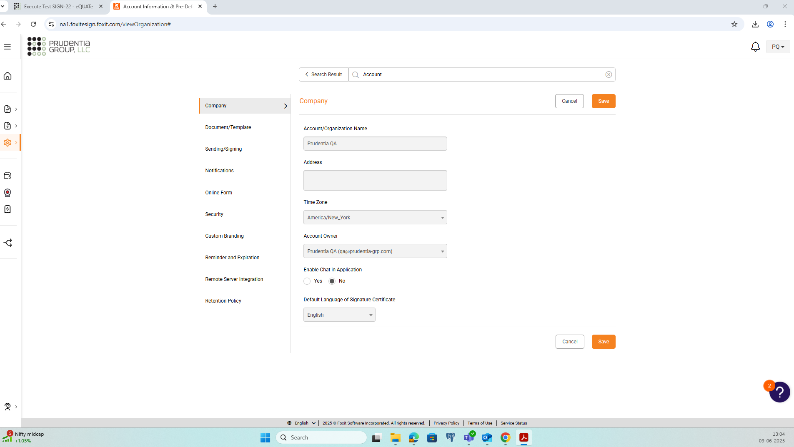
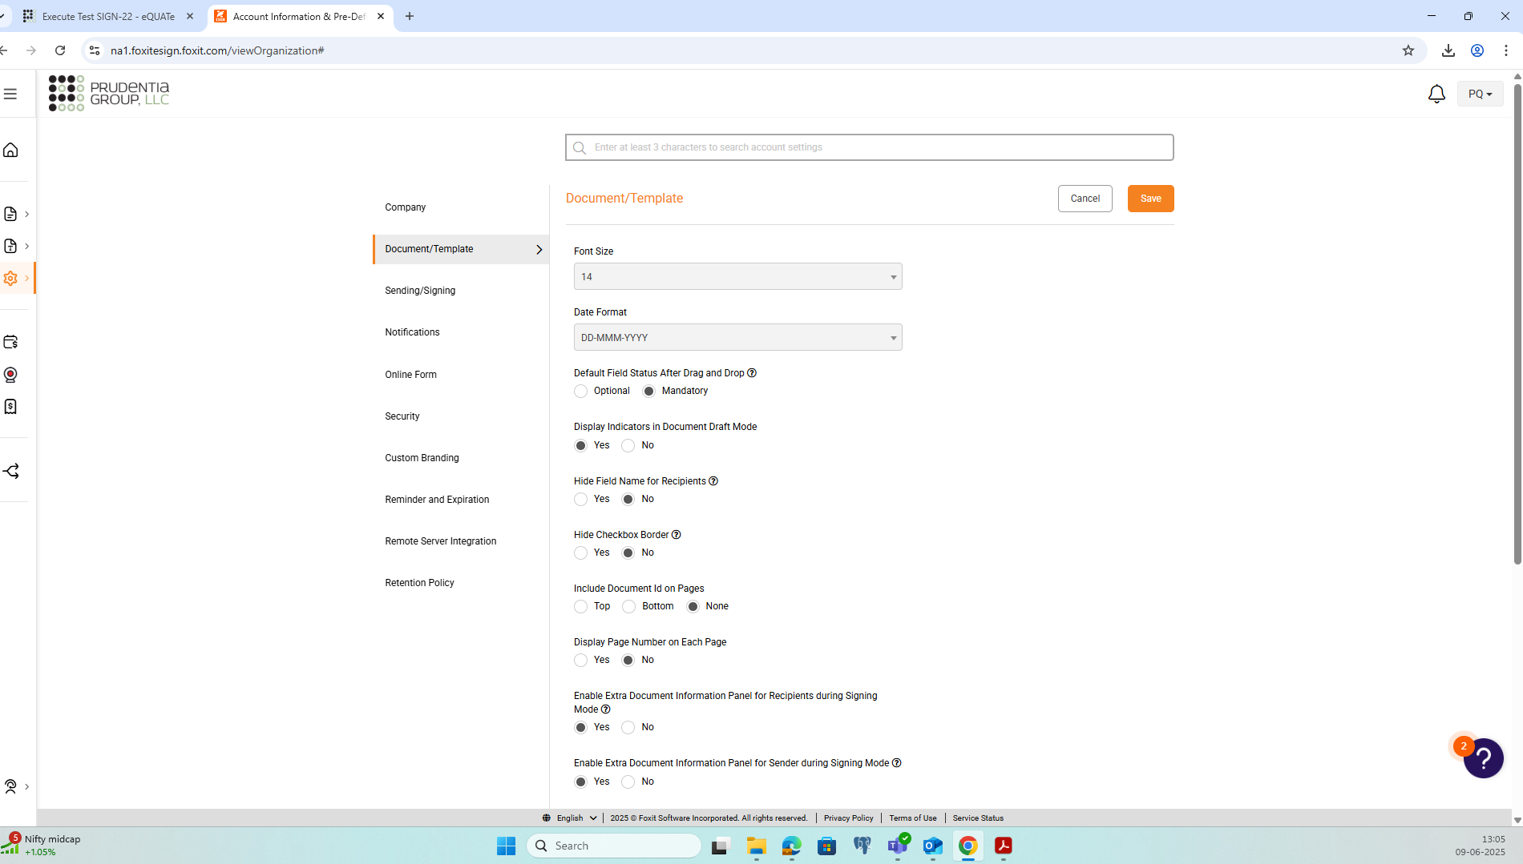
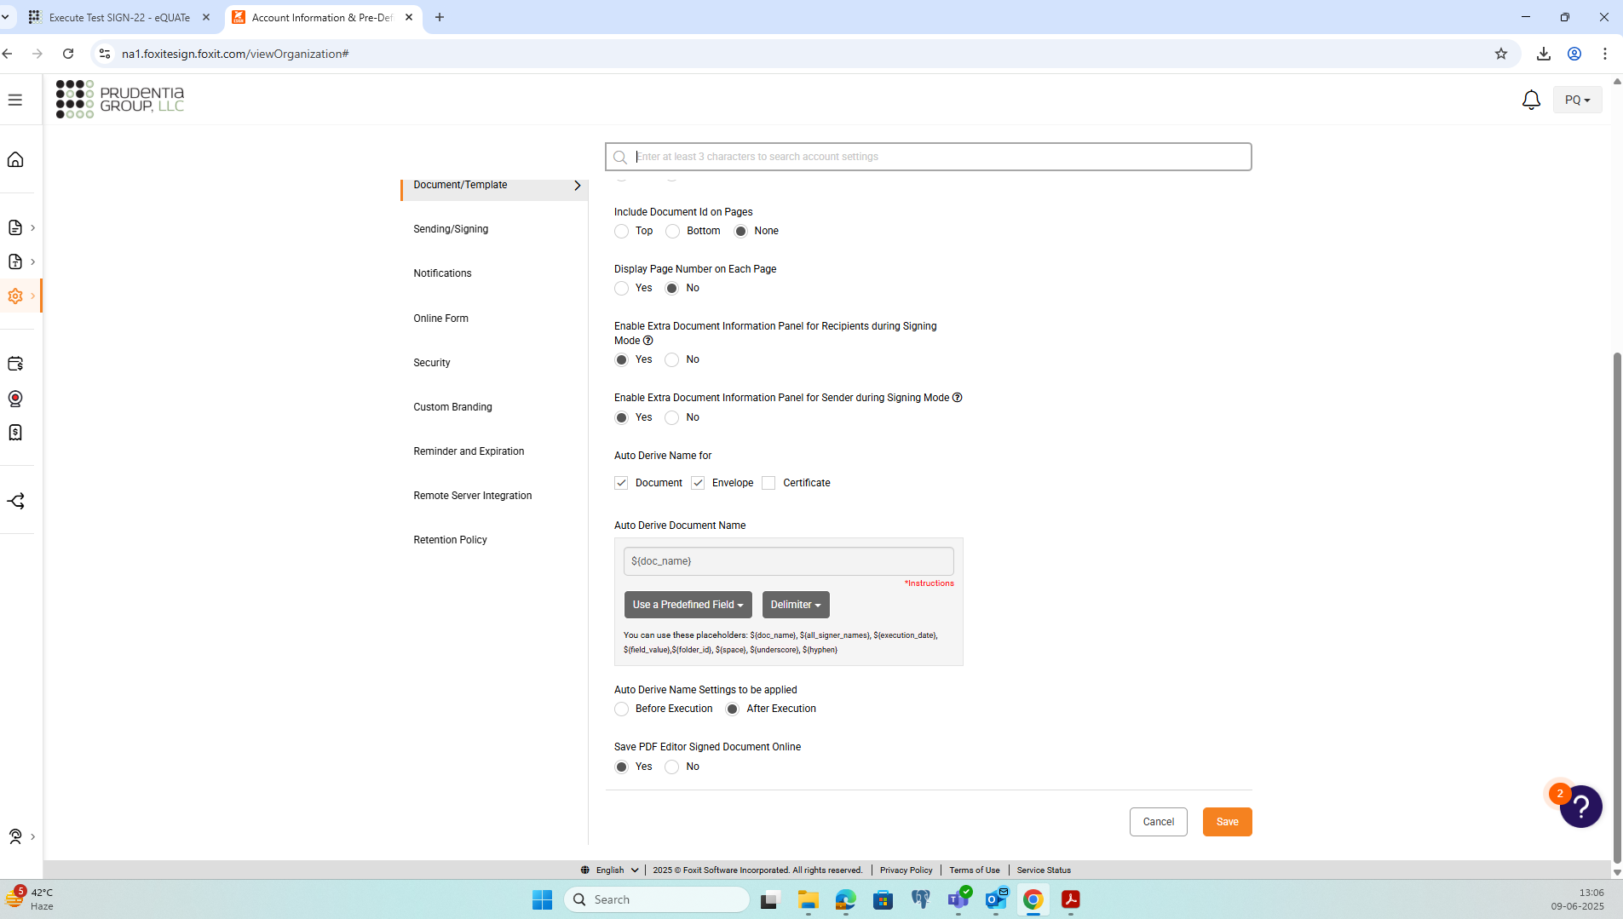
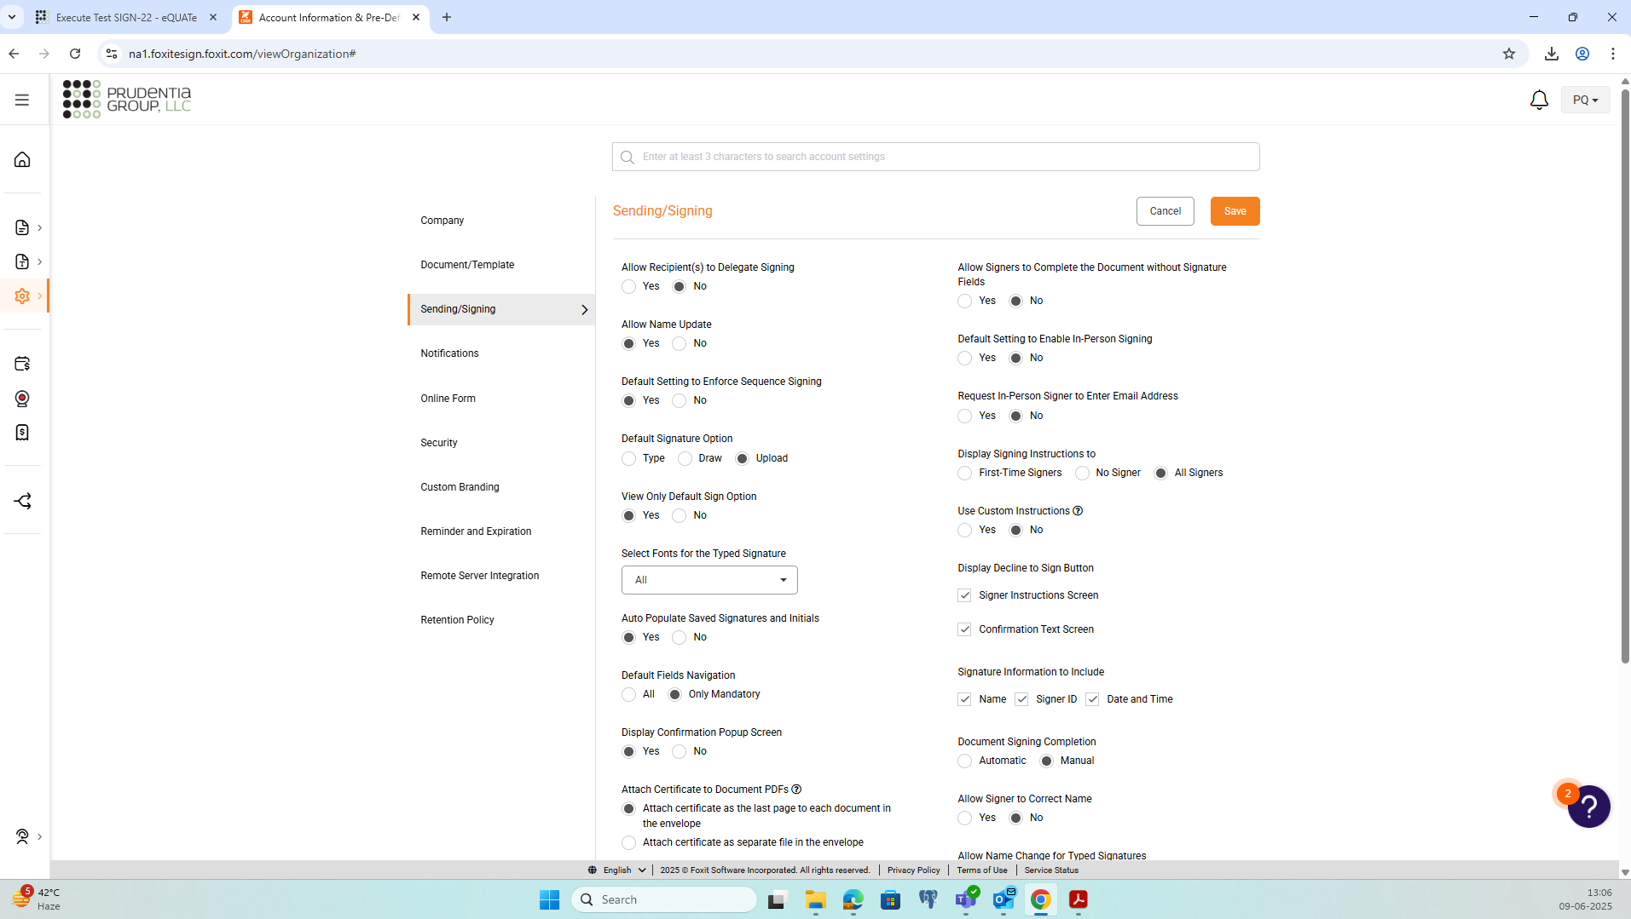
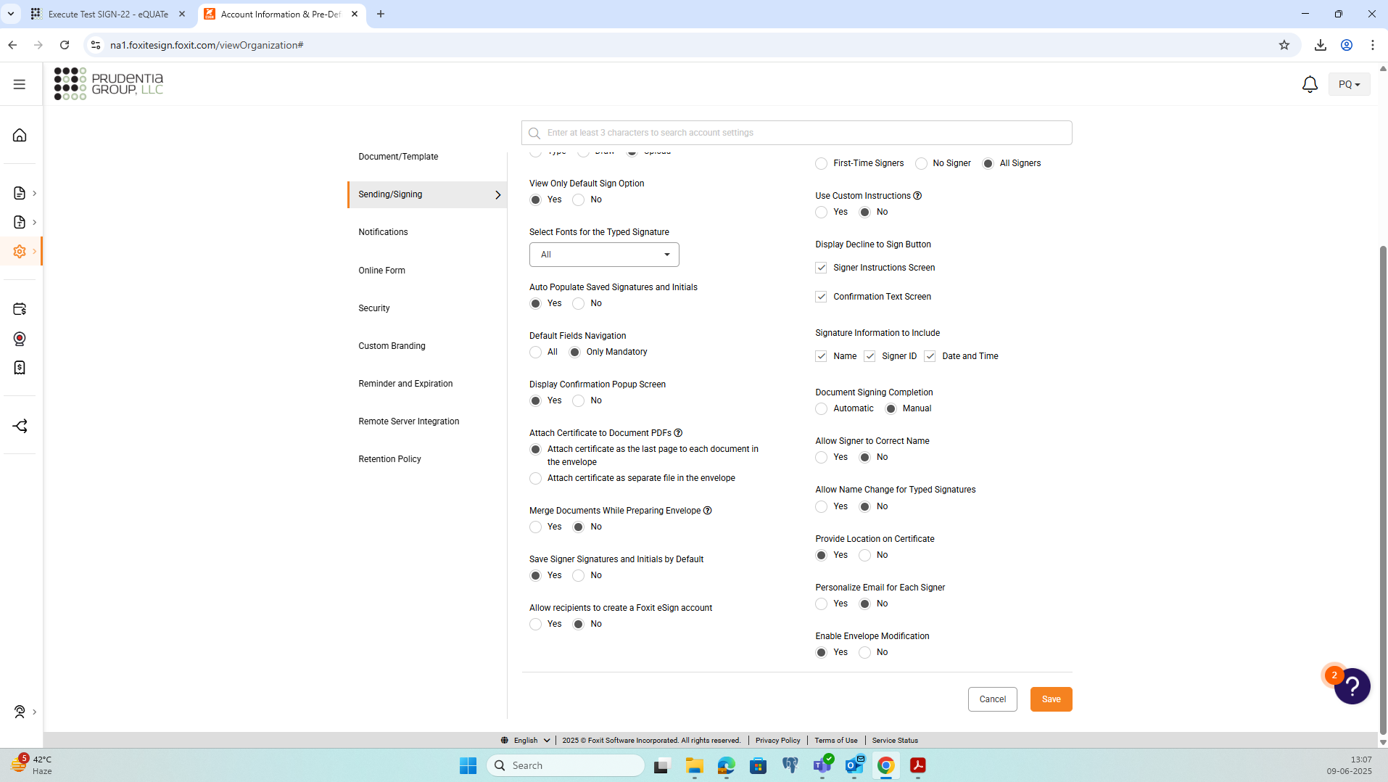
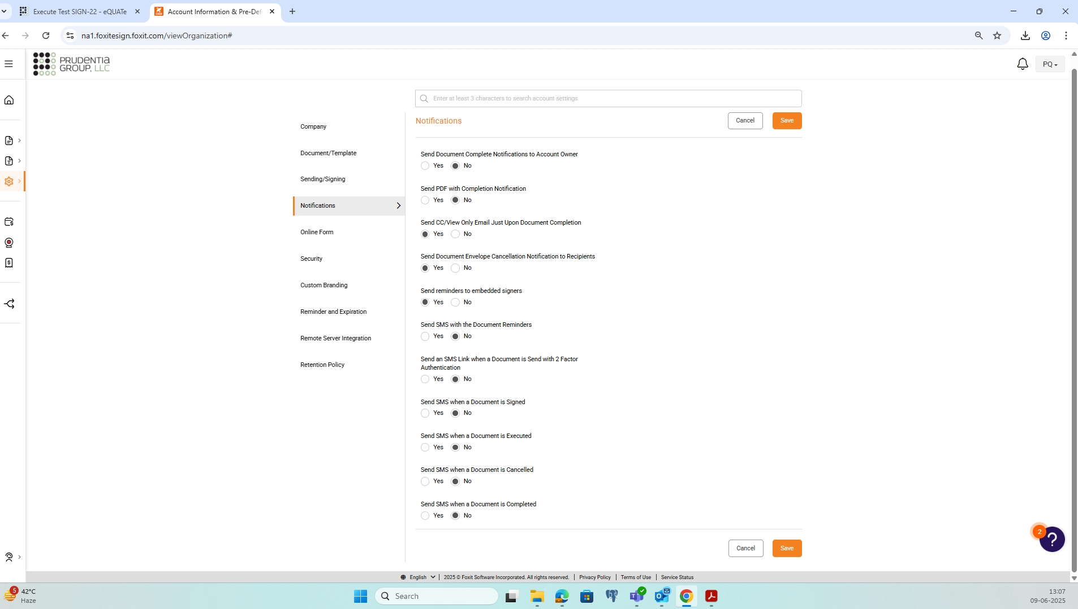
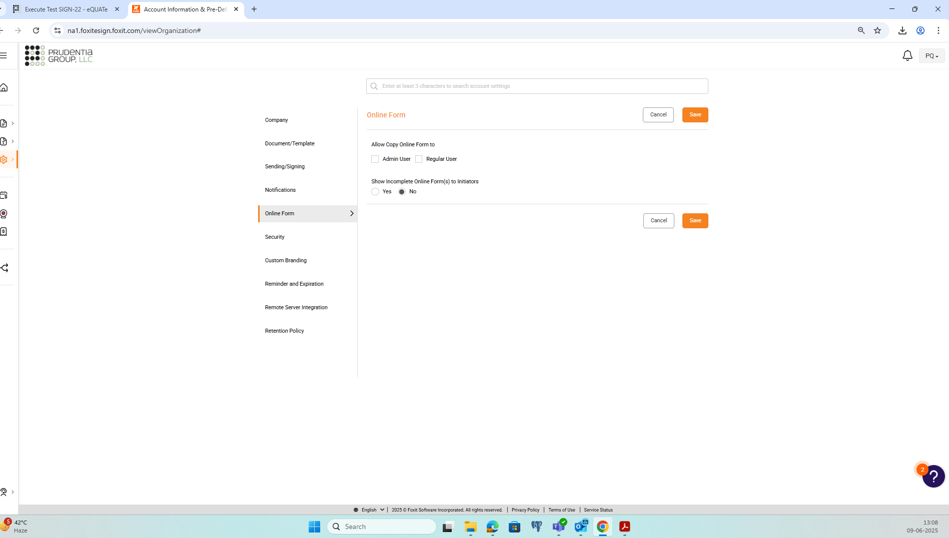
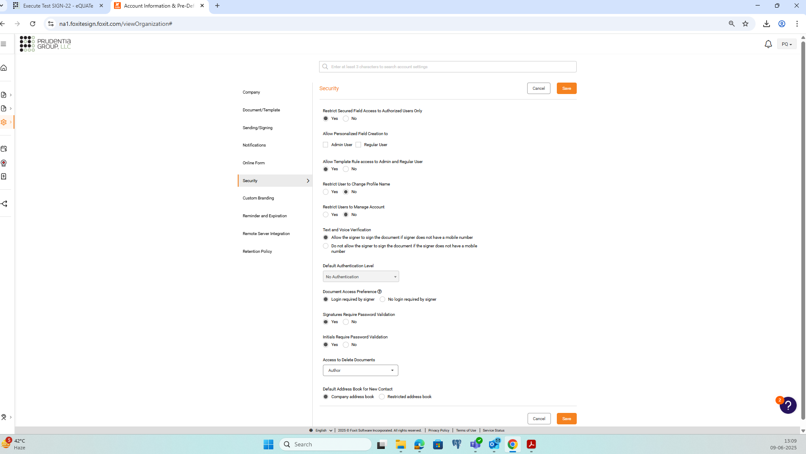
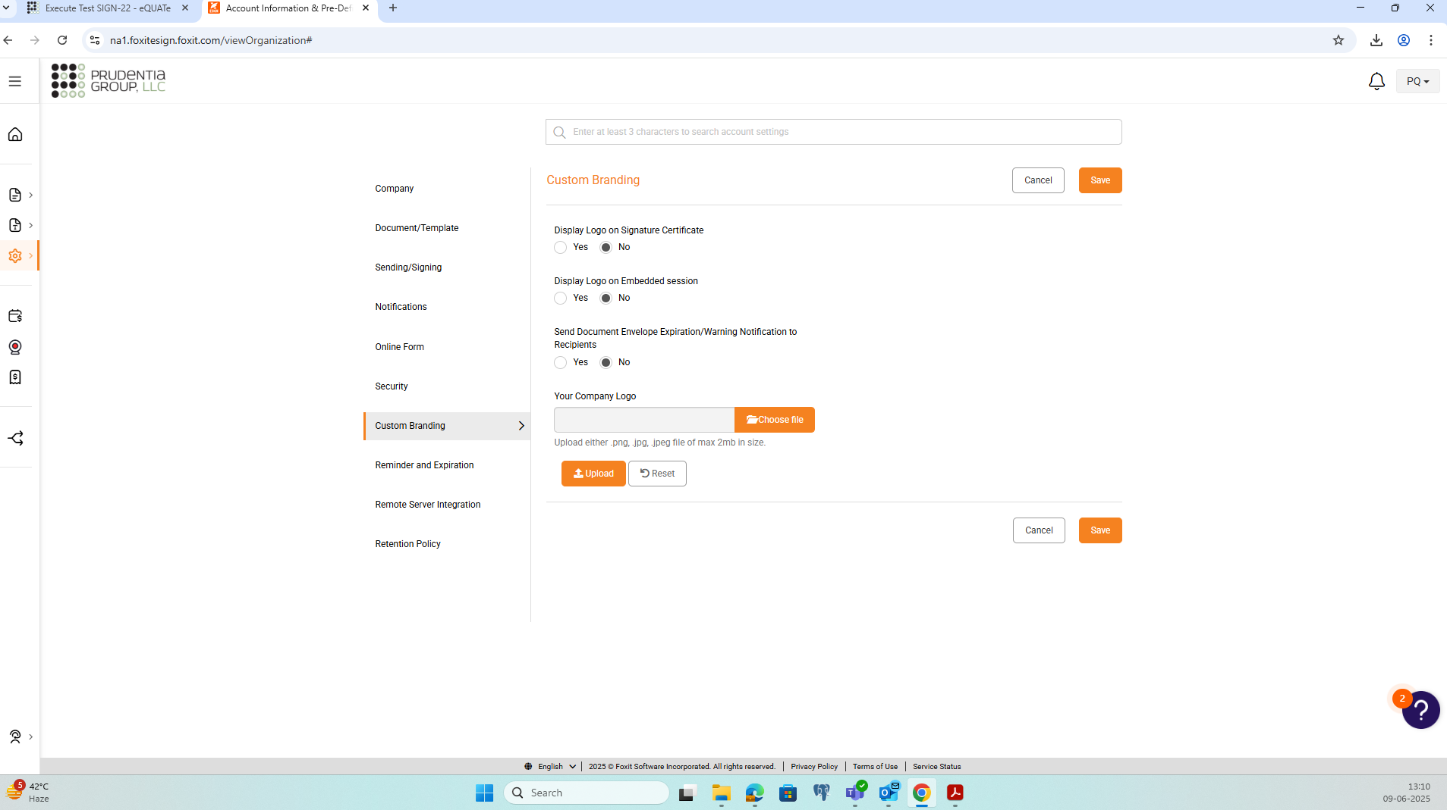
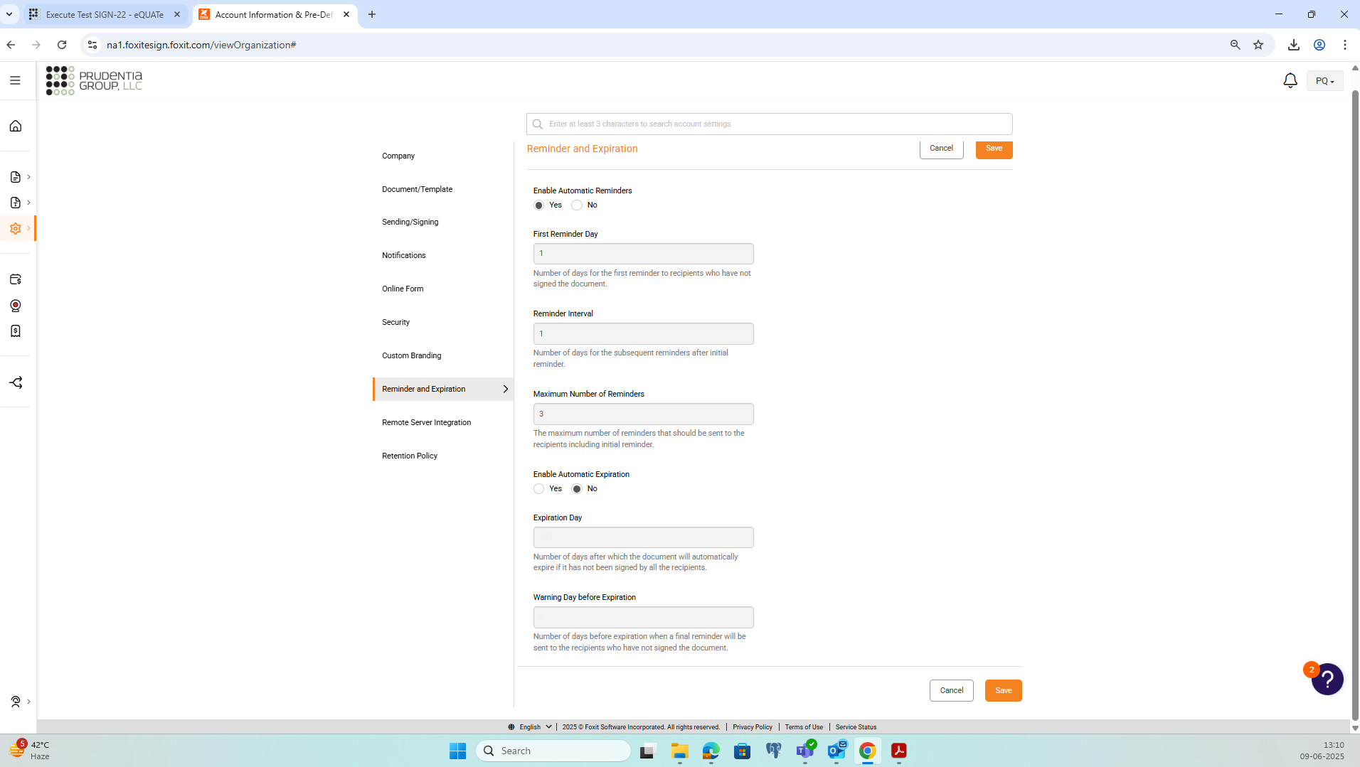
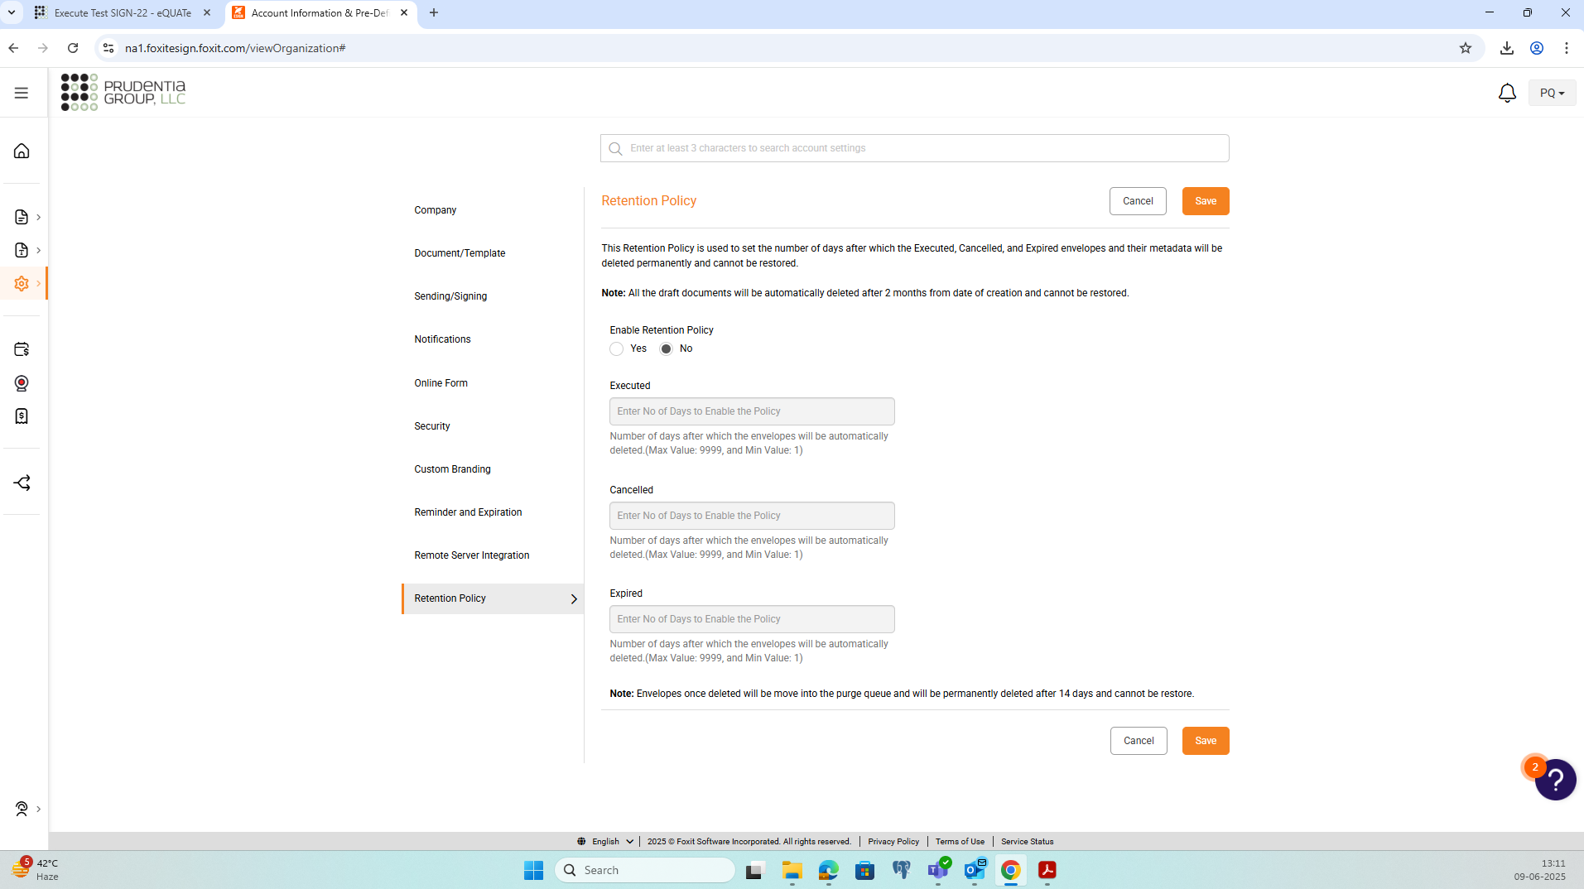

Step No. | Step Description |  | Step Data | Expected Results | Pre-Execution Attachments
5 | Upload <Test Document> to eQMS-Sign. |  | NA | The uploaded document is displayed in eQMS-Sign. | NA
Evidence |  | Discrepancy |  | Actual Results | Status
NA |  | NA |  | As expected. | PASS

Step No. | Step Description |  | Step Data | Expected Results | Pre-Execution Attachments
6 | Navigate to the 'Documents' dashboard in eQMS-Sign.  Take screenshots as evidence. |  | NA | <Test Document> is displayed with status DRAFT.  Screenshot attached. | NA
Evidence |  | Discrepancy |  | Actual Results | Status
screenshot-13_Step#6.png |  | NA |  | As expected. | PASS

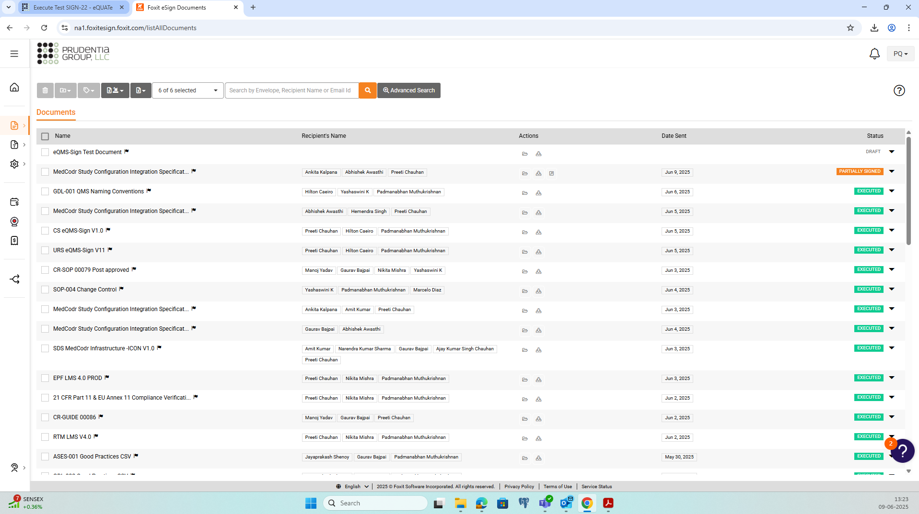

Step No. | Step Description |  | Step Data | Expected Results | Pre-Execution Attachments
7 | Open <Test Document> and navigate to 'Add Signers' screen.  Add <Contact1> and <Contact2> in "Add Recipient/Signer".  Set the following parameters:  - Enforce Signing Sequence: Yes  - Enable In Person Signing: No  - Authentication Level: No Authentication  - <Contact1>: Fill Out Fields and Sign  - <Contact2>: Fill Out Fields only |  | NA | Required data set/added in eQMS-Sign | NA
Evidence |  | Discrepancy |  | Actual Results | Status
NA |  | NA |  | As expected. | PASS

Step No. | Step Description |  | Step Data | Expected Results | Pre-Execution Attachments
8 | Navigate to the 'Prepare' screen and add the following fields:  - Section "Document Preparation": Signature Field and Date Signed Field  - Section "Document Reviewers": Initial Field and Date Signed Field |  | NA | Required fields added in eQMS-Sign | NA
Evidence |  | Discrepancy |  | Actual Results | Status
NA |  | NA |  | As expected. | PASS

Step No. | Step Description |  | Step Data | Expected Results | Pre-Execution Attachments
9 | For "Field Properties" set the following:  Signature Field in "Document Preparation" section  - Signature Field Properties: < Contact1>  Date Signed Field in "Document Preparation" section  - Date Field Properties: < Contact1>  Initial Field in "Document Reviewers" section  - Initials Field Properties: < Contact2>  Date Field in "Document Reviewers" section  - Date Field Properties: < Contact2> |  | NA | Required data set/added in eQMS-Sign | NA
Evidence |  | Discrepancy |  | Actual Results | Status
NA |  | NA |  | As expected. | PASS

Step No. | Step Description |  | Step Data | Expected Results | Pre-Execution Attachments
10 | Navigate to the 'Send' screen and send out the document for signatures. |  | NA | The document is sent out for signatures. | NA
Evidence |  | Discrepancy |  | Actual Results | Status
NA |  | NA |  | As expected. | PASS

Step No. | Step Description |  | Step Data | Expected Results | Pre-Execution Attachments
11 | Navigate to the 'Documents' dashboard in eQMS-Sign.  Take screenshots as evidence. |  | NA | The document <Test Document> is displayed with status SHARED.  Screenshot attached. | NA
Evidence |  | Discrepancy |  | Actual Results | Status
screenshot-14_Step#11.png |  | NA |  | As expected. | PASS

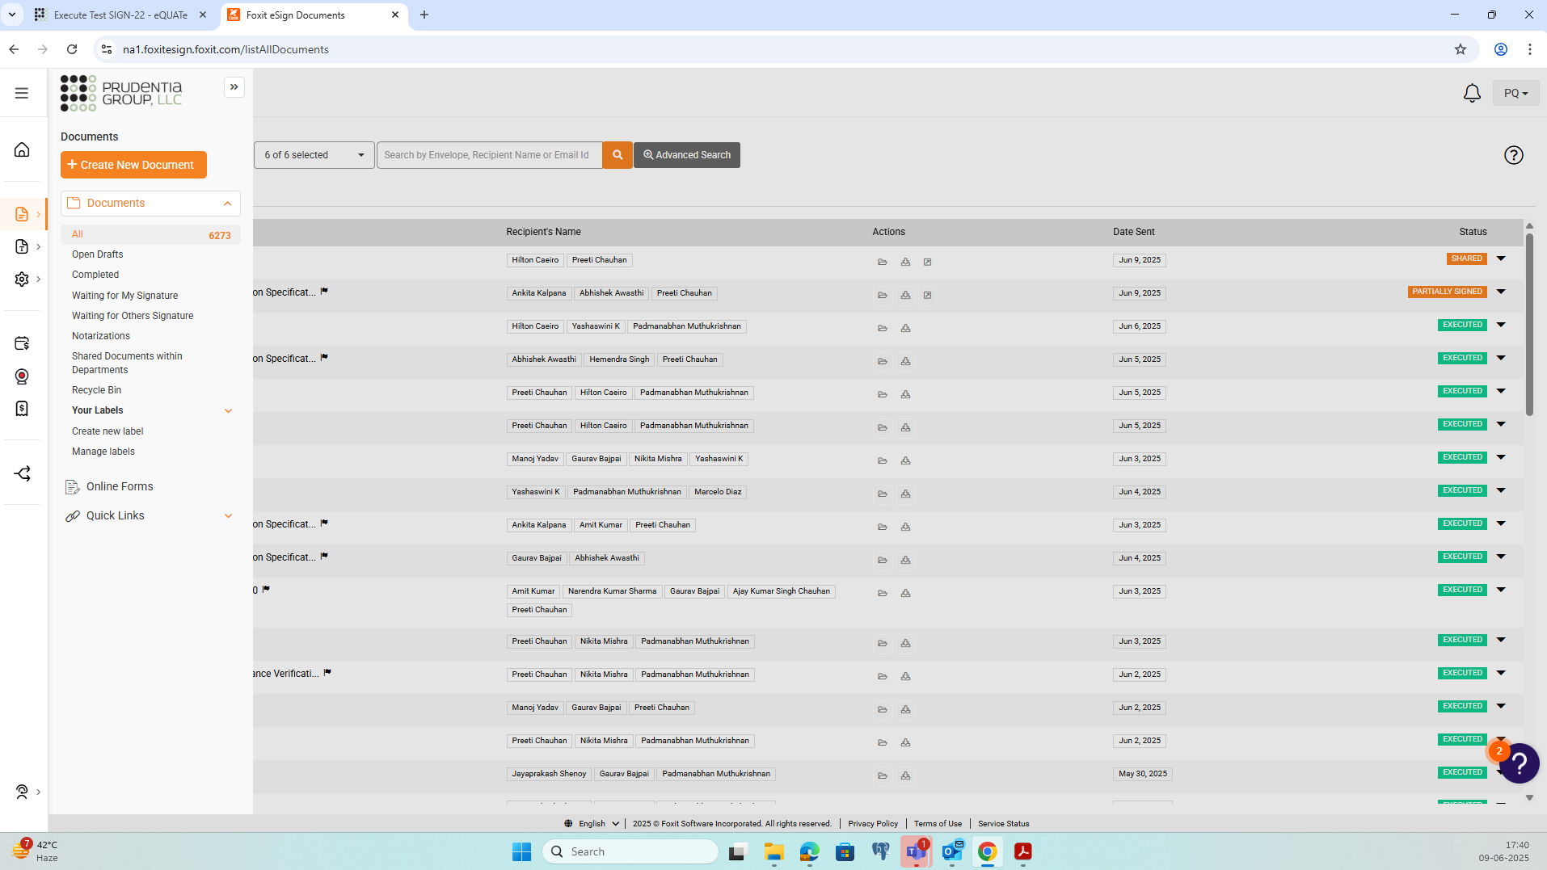

Step No. | Step Description |  | Step Data | Expected Results | Pre-Execution Attachments
12 | Log out from eQMS-Sign. |  | NA | Tester is logged out from eQMS-Sign. | NA
Evidence |  | Discrepancy |  | Actual Results | Status
NA |  | NA |  | As expected. | PASS

Step No. | Step Description |  | Step Data | Expected Results | Pre-Execution Attachments
13 | Confirm that <Contact1> has received a notification from eQMS-Sign.  Attach the email as evidence. |  | NA | Confirmed that a notification has been received by <Contact1>.  Notification email attached as evidence. | NA
Evidence |  | Discrepancy |  | Actual Results | Status
Notification_Step#13.pdf |  | NA |  | As expected. | PASS

Step No. | Step Description |  | Step Data | Expected Results | Pre-Execution Attachments
14 | Click on the link to access the document in the notification email.  On the eQMS-Sign login page, login using account <Contact1>.  Accept the instructions shown by eQMS-Sign till you can view the document to be signed. |  | NA | The document <Test Document> will be displayed. | NA
Evidence |  | Discrepancy |  | Actual Results | Status
NA |  | NA |  | As expected. | PASS

Step No. | Step Description |  | Step Data | Expected Results | Pre-Execution Attachments
15 | Click on the Signature field under section "Document Preparation".  In the pop-up window asking <Contact1> to authenticate his/her password, keep the password blank or enter a wrong password and try to authenticate.  Take a screenshot. |  | NA | eQMS-Sign will notify that the password is incorrect.  Screenshot is attached. | NA
Evidence |  | Discrepancy |  | Actual Results | Status
screenshot-15_Step#15.png |  | NA |  | As expected. | PASS

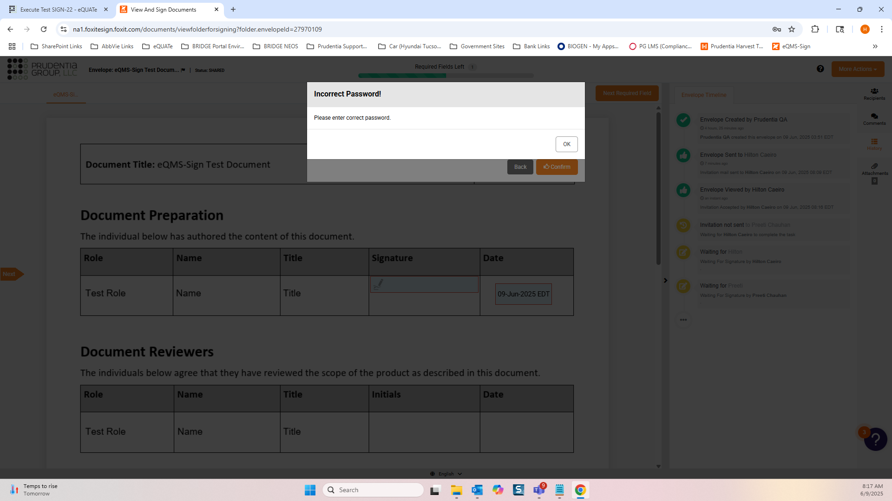

Step No. | Step Description |  | Step Data | Expected Results | Pre-Execution Attachments
16 | Enter the correct password for <Contact1>. |  | NA | The signature for <Contact1> will be applied and the date field will be auto populated. | NA
Evidence |  | Discrepancy |  | Actual Results | Status
NA |  | NA |  | As expected. | PASS

Step No. | Step Description |  | Step Data | Expected Results | Pre-Execution Attachments
17 | Click on the 'Finish' button, accept the agreement in the popup screen and sign the document to confirm the application of the signature for <Contact 1>.  Verify that the Initial Field is not displayed under section "Document Reviewers".  Take a screenshot. |  | NA | Verified that the Initial Field is not displayed under section "Document Reviewers".  Screenshot is attached. | NA
Evidence |  | Discrepancy |  | Actual Results | Status
screenshot-16_Step#17.png |  | NA |  | As expected. | PASS

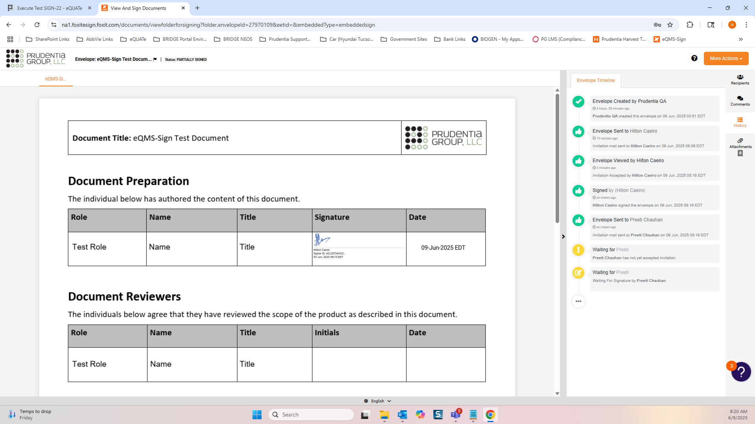

Step No. | Step Description |  | Step Data | Expected Results | Pre-Execution Attachments
18 | Log out from eQMS-Sign. |  | NA | Tester is logged out from eQMS-Sign. | NA
Evidence |  | Discrepancy |  | Actual Results | Status
NA |  | NA |  | As expected. | PASS

Step No. | Step Description |  | Step Data | Expected Results | Pre-Execution Attachments
19 | Confirm that <Contact2> has received a notification from eQMS-Sign.  Attach the email as evidence. |  | NA | Confirmed that notification has been received by <Contact2>.  Notification email attached as evidence. | NA
Evidence |  | Discrepancy |  | Actual Results | Status
Notification_Step#19.pdf |  | NA |  | As expected. | PASS

Step No. | Step Description |  | Step Data | Expected Results | Pre-Execution Attachments
20 | Click on the link to access the document in the notification email.  On the eQMS-Sign login page, login using account <Contact2>. |  | NA | The document <Test Document> will be displayed. | NA
Evidence |  | Discrepancy |  | Actual Results | Status
NA |  | NA |  | As expected. | PASS

Step No. | Step Description |  | Step Data | Expected Results | Pre-Execution Attachments
21 | Click on the Initial field under section "Document Reviewers".  Authenticate <Contact2> in the pop-up window asking <Contact2> to authenticate his/her password.  Click on the 'Finish' button, accept the agreement in the popup screen and sign the document to confirm the application of the initial for <Contact 2>.  Take a screenshot. |  | NA | The initial for <Contact2> will be applied and the date field will be auto populated.  Screenshot is attached. | NA
Evidence |  | Discrepancy |  | Actual Results | Status
screenshot-17_Step#21.png |  | NA |  | As expected. | PASS

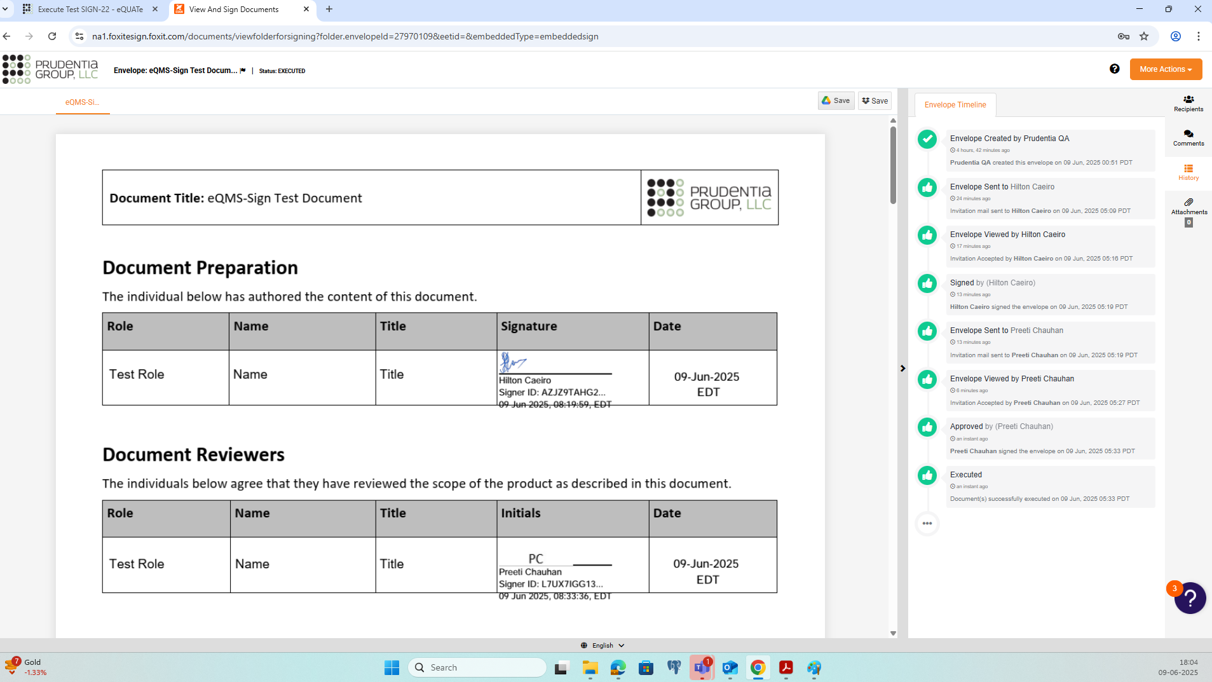

Step No. | Step Description |  | Step Data | Expected Results | Pre-Execution Attachments
22 | Log out from eQMS-Sign. |  | NA | Tester is logged out from eQMS-Sign. | NA
Evidence |  | Discrepancy |  | Actual Results | Status
NA |  | NA |  | As expected. | PASS

Step No. | Step Description |  | Step Data | Expected Results | Pre-Execution Attachments
23 | Confirm that <Admin User> has received a notification from eQMS-Sign that the document is executed.  Attach the email as evidence. |  | NA | Confirmed that a notification has been received by <Admin User>.  Notification email attached as evidence. | NA
Evidence |  | Discrepancy |  | Actual Results | Status
Notification_Step#23.pdf |  | NA |  | As expected. | PASS

Step No. | Step Description |  | Step Data | Expected Results | Pre-Execution Attachments
24 | Login to eQMS-Sign using <Admin User>.  Navigate to the 'Documents' dashboard in eQMS-Sign.  Take screenshots as evidence. |  | NA | The document <Test Document> is displayed with status EXECUTED.  Screenshot attached. | NA
Evidence |  | Discrepancy |  | Actual Results | Status
screenshot-18_Step#24.png |  | NA |  | As expected. | PASS

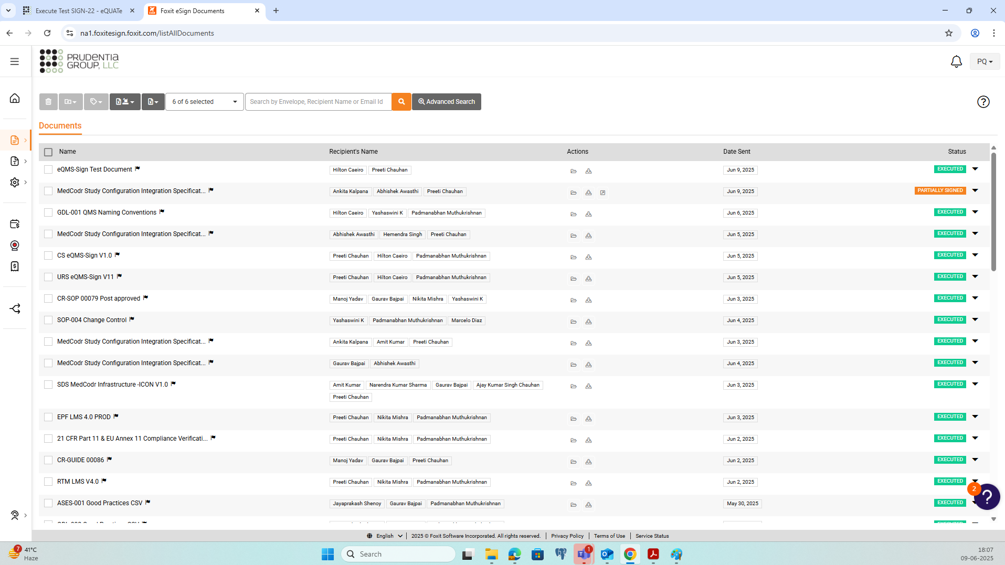

Step No. | Step Description |  | Step Data | Expected Results | Pre-Execution Attachments
25 | Download the executed <Test Document> and attach it as evidence. |  | NA | The document <Test Document> will be fully signed by <Contact1> and <Contact2>.  The audit trail of the signature process will be appended to the downloaded document.  Executed document attached as evidence. | NA
Evidence |  | Discrepancy |  | Actual Results | Status
eQMS-Sign Test Document_Step#25.pdf |  | NA |  | As expected. | PASS

Step No. | Step Description |  | Step Data | Expected Results | Pre-Execution Attachments
26 | Log out from eQMS-Sign. |  | NA | Tester is logged out from eQMS-Sign. | NA
Evidence |  | Discrepancy |  | Actual Results | Status
NA |  | NA |  | As expected. | PASS

Step No. | Step Description |  | Step Data | Expected Results | Pre-Execution Attachments
27 | Login to eQMS-Sign using <Regular User>.  Upload <Test Document> to eQMS-Sign. |  | NA | The uploaded document is displayed in eQMS-Sign. | NA
Evidence |  | Discrepancy |  | Actual Results | Status
NA |  | NA |  | As expected. | PASS

Step No. | Step Description |  | Step Data | Expected Results | Pre-Execution Attachments
28 | Navigate to 'Add Signers' screen.  Add <Contact1> & <Contact2> in "Add Recipient/Signer".  Set the following parameters:  - Enforce Signing Sequence: Yes  - Enable In Person Signing: No  - Authentication Level: No Authentication  - <Contact1>: CC/View Only  - <Contact2>: Fill Out Fields and Sign |  | NA | Required data set/added in eQMS-Sign | NA
Evidence |  | Discrepancy |  | Actual Results | Status
NA |  | NA |  | As expected. | PASS

Step No. | Step Description |  | Step Data | Expected Results | Pre-Execution Attachments
29 | Navigate to the 'Prepare' screen and add the following fields:  - Section "Document Preparation": Signature Field and Date Field |  | NA | Required fields added in eQMS-Sign | NA
Evidence |  | Discrepancy |  | Actual Results | Status
NA |  | NA |  | As expected. | PASS

Step No. | Step Description |  | Step Data | Expected Results | Pre-Execution Attachments
30 | For "Field Properties" set the following:  Signature Field in "Document Preparation" section  - Signature Field Properties: <Contact2>  Date Field in "Document Preparation" section  - Date Field Properties: <Contact2> |  | NA | Required data set/added in eQMS-Sign | NA
Evidence |  | Discrepancy |  | Actual Results | Status
NA |  | NA |  | As expected. | PASS

Step No. | Step Description |  | Step Data | Expected Results | Pre-Execution Attachments
31 | Navigate to the 'Send' screen and send out the document for signatures. |  | NA | The document is sent out for signatures. | NA
Evidence |  | Discrepancy |  | Actual Results | Status
NA |  | NA |  | As expected. | PASS

Step No. | Step Description |  | Step Data | Expected Results | Pre-Execution Attachments
32 | Log out from eQMS-Sign. |  | NA | Tester is logged out from eQMS-Sign. | NA
Evidence |  | Discrepancy |  | Actual Results | Status
NA |  | NA |  | As expected. | PASS

Step No. | Step Description |  | Step Data | Expected Results | Pre-Execution Attachments
33 | Confirm that <Contact2> has received a notification from eQMS-Sign.  Attach the email as evidence. |  | NA | Confirmed that a notification has been received by <Contact2>.  Notification email attached as evidence. | NA
Evidence |  | Discrepancy |  | Actual Results | Status
Notification_Step#33.pdf |  | NA |  | As expected. | PASS

Step No. | Step Description |  | Step Data | Expected Results | Pre-Execution Attachments
34 | Click on the link to access the document in the notification email.  On the eQMS-Sign login page, login using account <Contact2>.  Accept the instructions shown by eQMS-Sign till you can view the document to be signed. |  | NA | The document <Test Document> will be displayed. | NA
Evidence |  | Discrepancy |  | Actual Results | Status
NA |  | NA |  | As expected. | PASS

Step No. | Step Description |  | Step Data | Expected Results | Pre-Execution Attachments
35 | Click on the Date field under section Document Preparation and enter a date of your choice.  Take a screenshot. |  | NA | The Date field will be updated with the date chosen by the tester.  Screenshot is attached. | NA
Evidence |  | Discrepancy |  | Actual Results | Status
screenshot-19_Step#35.png |  | NA |  | As expected. | PASS

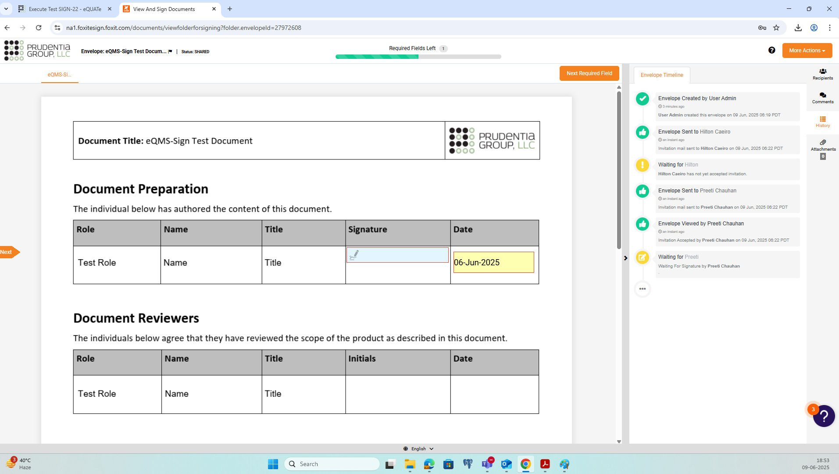

Step No. | Step Description |  | Step Data | Expected Results | Pre-Execution Attachments
36 | Click on the Signature field under section Document Preparation.  Enter the correct password for <Contact2>.  Click on the 'Finish' button, accept the agreement in the popup screen and sign the document to confirm the application of the initial for <Contact 2>.  Take a screenshot. |  | NA | The signature for <Contact2> will be applied.  Screenshot is attached. | NA
Evidence |  | Discrepancy |  | Actual Results | Status
screenshot-20_Step#36.png |  | NA |  | As expected. | PASS

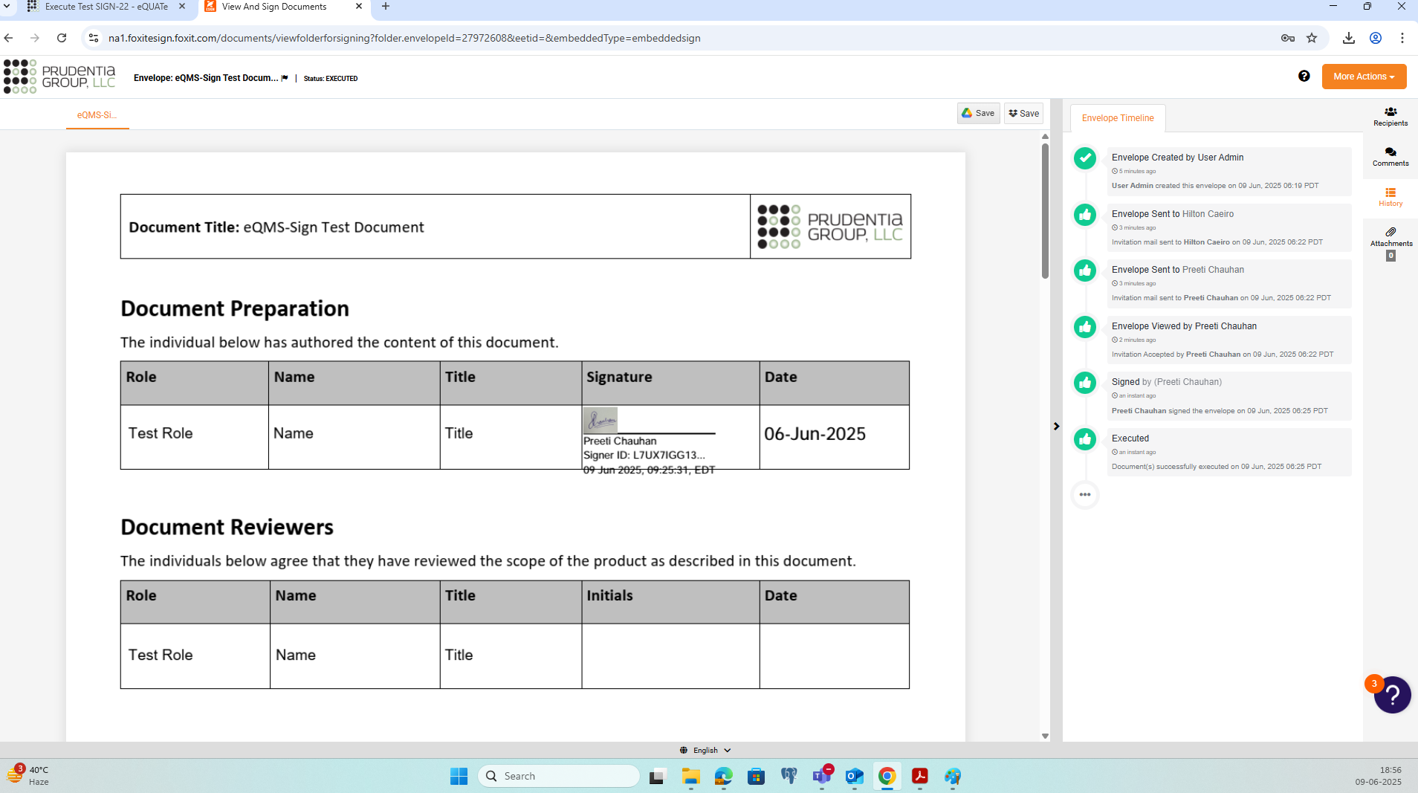

Step No. | Step Description |  | Step Data | Expected Results | Pre-Execution Attachments
37 | Confirm that <Contact1> has received a notification from eQMS-Sign that the document is executed.  Attach the email as evidence.  Also verify that <Admin User> has not received a notification from eQMS-Sign that the document is executed. |  | NA | Confirmed that a notification has been received by <Contact1>.  Notification email attached as evidence.  Confirmed that a notification has not been received by <Admin User>. | NA
Evidence |  | Discrepancy |  | Actual Results | Status
Notification_Step#37.pdf |  | NA |  | As expected. | PASS

Step No. | Step Description |  | Step Data | Expected Results | Pre-Execution Attachments
38 | Log out from eQMS-Sign. |  | NA | Tester is logged out from eQMS-Sign. | NA
Evidence |  | Discrepancy |  | Actual Results | Status
NA |  | NA |  | As expected. | PASS

Step No. | Step Description |  | Step Data | Expected Results | Pre-Execution Attachments
39 | Login to eQMS-Sign using <Regular User>.  Verify that <Regular User> does not have the option to access Settings in eQMS-Sign.  Take screenshots as evidence. |  | NA | Verified that <Regular User> does not have the option to access Settings in eQMS-Sign.  Screenshot attached. | NA
Evidence |  | Discrepancy |  | Actual Results | Status
screenshot-21_Step#39.png |  | NA |  | As expected. | PASS

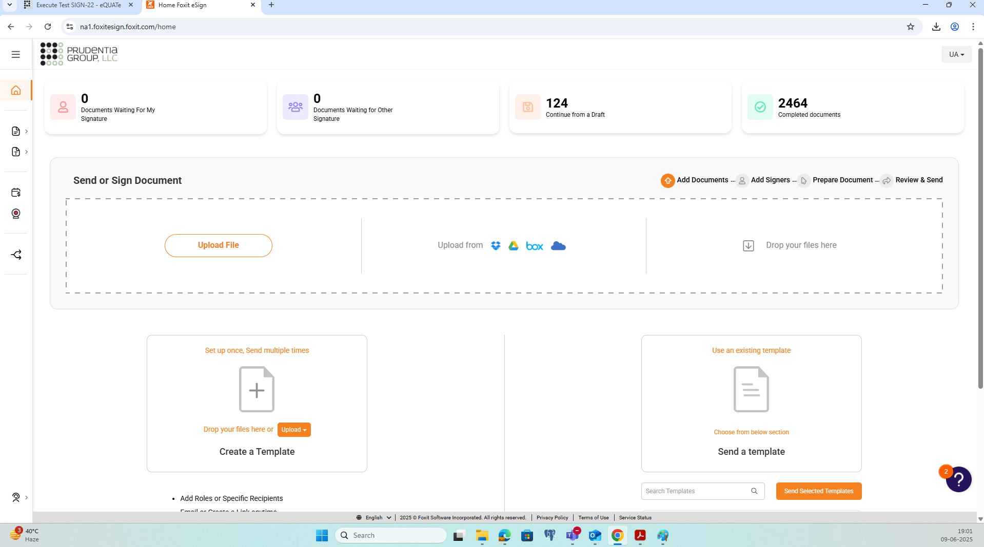

Step No. | Step Description |  | Step Data | Expected Results | Pre-Execution Attachments
40 | Add a new contact in the address book. (User will have to upload <Test Document> and click on Add New in the Recipient Parties)  Confirm the user can add the following fields:  - First Name  - Last Name  - Email ID  - Mobile Number (Optional)  Take screenshots as evidence. |  | NA | Confirmed that the user can add the information specified in the test step.  Screenshot attached. | NA
Evidence |  | Discrepancy |  | Actual Results | Status
screenshot-22_Step#40.png |  | NA |  | As expected. | PASS

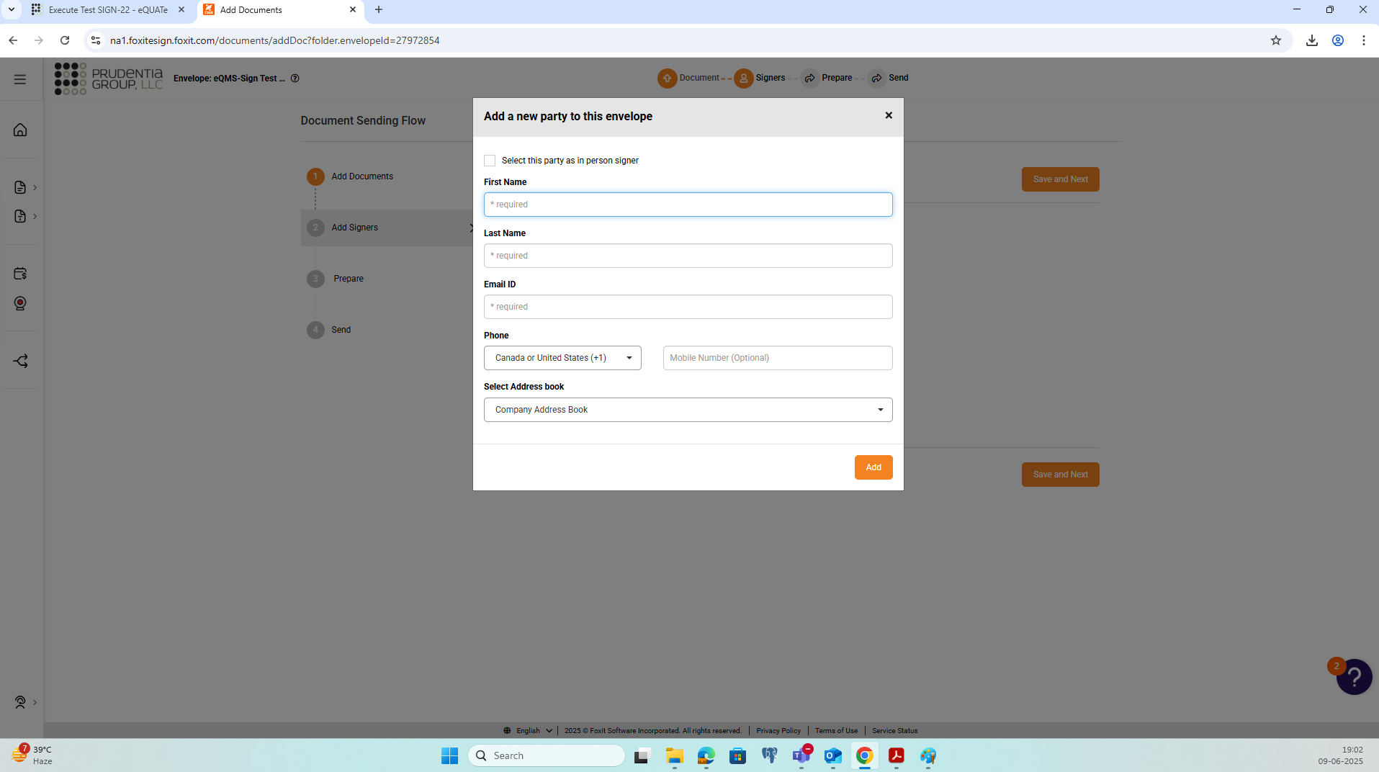

Step No. | Step Description |  | Step Data | Expected Results | Pre-Execution Attachments
41 | Log out from eQMS-Sign. |  | NA | Tester is logged out from eQMS-Sign. | NA
Evidence |  | Discrepancy |  | Actual Results | Status
NA |  | NA |  | As expected. | PASS

Step No. | Step Description |  | Step Data | Expected Results | Pre-Execution Attachments
42 | Login to eQMS-Sign using <Admin User>.  Confirm the user can add/update the following fields when adding a new user under account users:  - First Name  - Last Name  - Email ID  - Mobile Number (Optional)  - Department (Optional)  - Title (Optional)  - User Role  - Setting to share document with department administrator  - Setting to allow secure field access  - Manager  - Status  - No Authentication  Take screenshots as evidence. |  | NA | Confirmed that the user can add the information specified in the test step.  Screenshot attached. | NA
Evidence |  | Discrepancy |  | Actual Results | Status
screenshot-23_Step#42.png |  | NA |  | As expected. | PASS

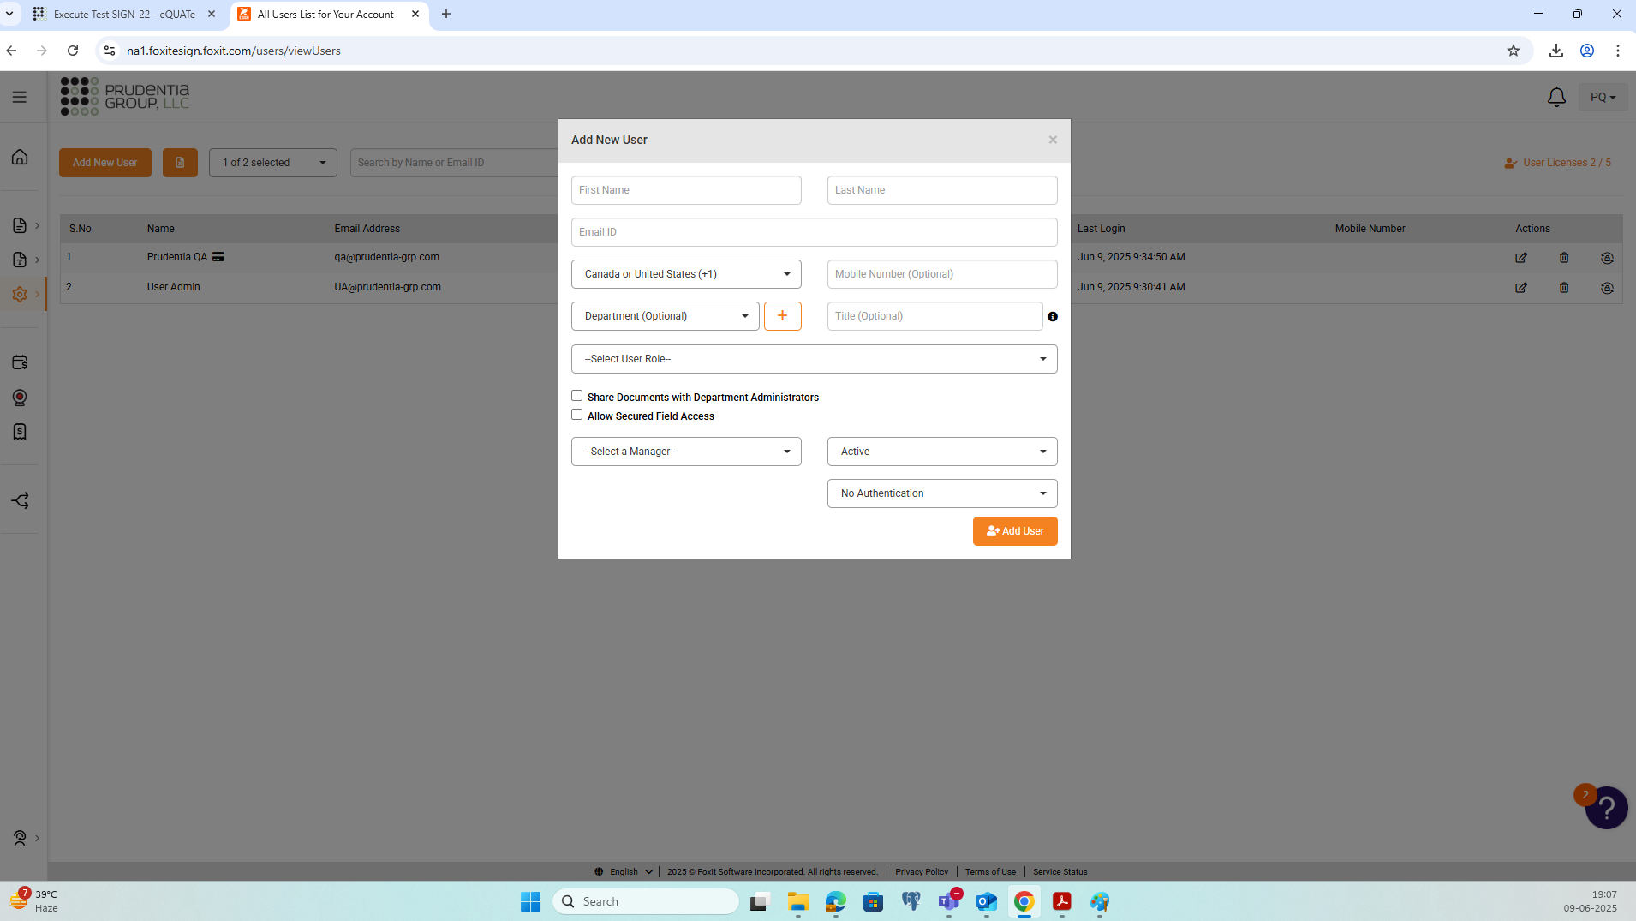

Step No. | Step Description |  | Step Data | Expected Results | Pre-Execution Attachments
43 | Confirm the user can add/update the following fields when adding a new contact in the address book:  - First Name  - Last Name  - Email ID  - Mobile Number (Optional)  - Organization (Optional)  - Description (Optional)  Take screenshots as evidence. |  | NA | Confirmed that the tester can add the information specified in the test step.  Screenshot attached. | NA
Evidence |  | Discrepancy |  | Actual Results | Status
screenshot-24_Step#43.png |  | NA |  | As expected. | PASS

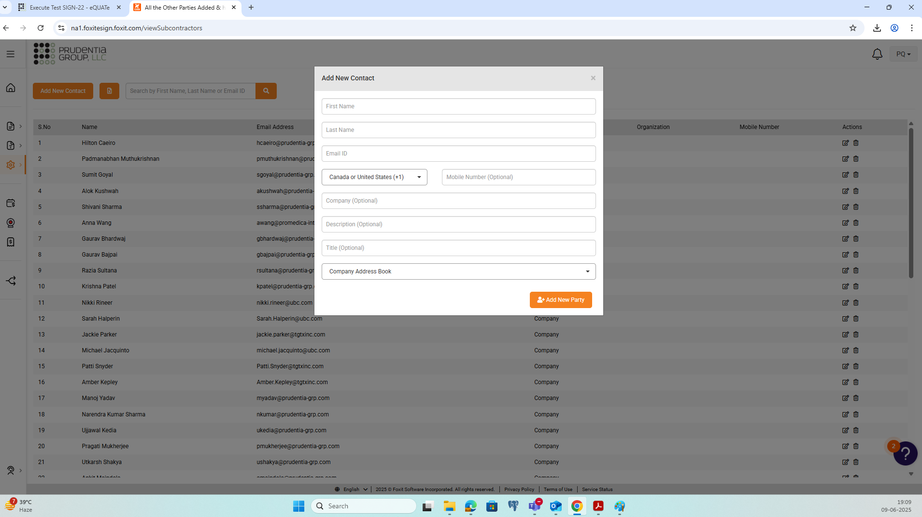

Step No. | Step Description |  | Step Data | Expected Results | Pre-Execution Attachments
44 | Search for <Regular User> in account users.  Verify that the user has an option to delete <Regular User>.  Take screenshots as evidence. |  | NA | Verified that the user has an option to delete <Regular User>.  Screenshot attached. | NA
Evidence |  | Discrepancy |  | Actual Results | Status
screenshot-25_Step#44.png |  | NA |  | As expected. | PASS

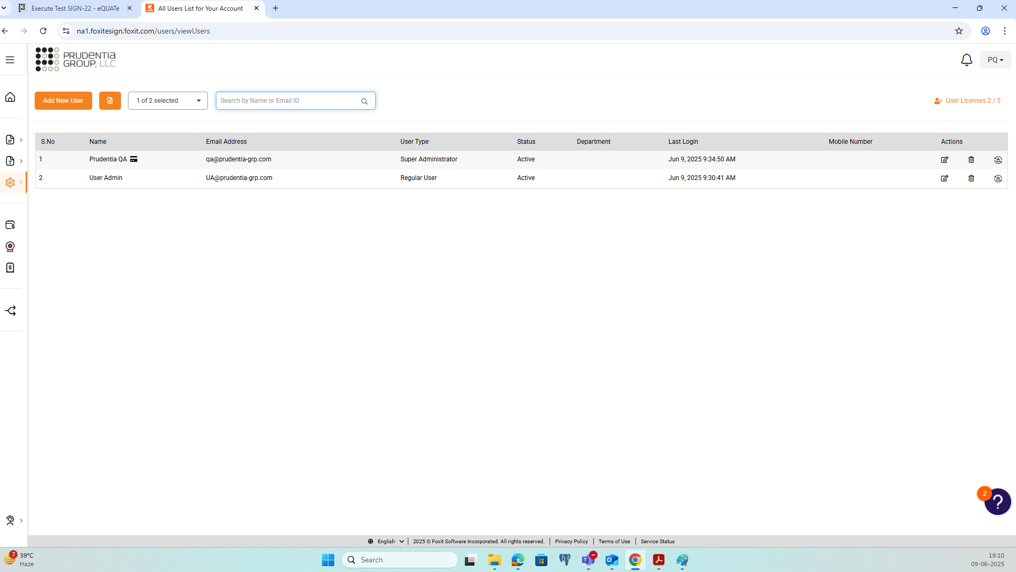

Step No. | Step Description |  | Step Data | Expected Results | Pre-Execution Attachments
45 | Search for <Contact1> in address book.  Verify that the user has an option to delete <Contact1>.  Take screenshots as evidence. |  | NA | Verified that the user has an option to delete <Contact1>.  Screenshot attached. | NA
Evidence |  | Discrepancy |  | Actual Results | Status
screenshot-26_Step#45.png |  | NA |  | As expected. | PASS

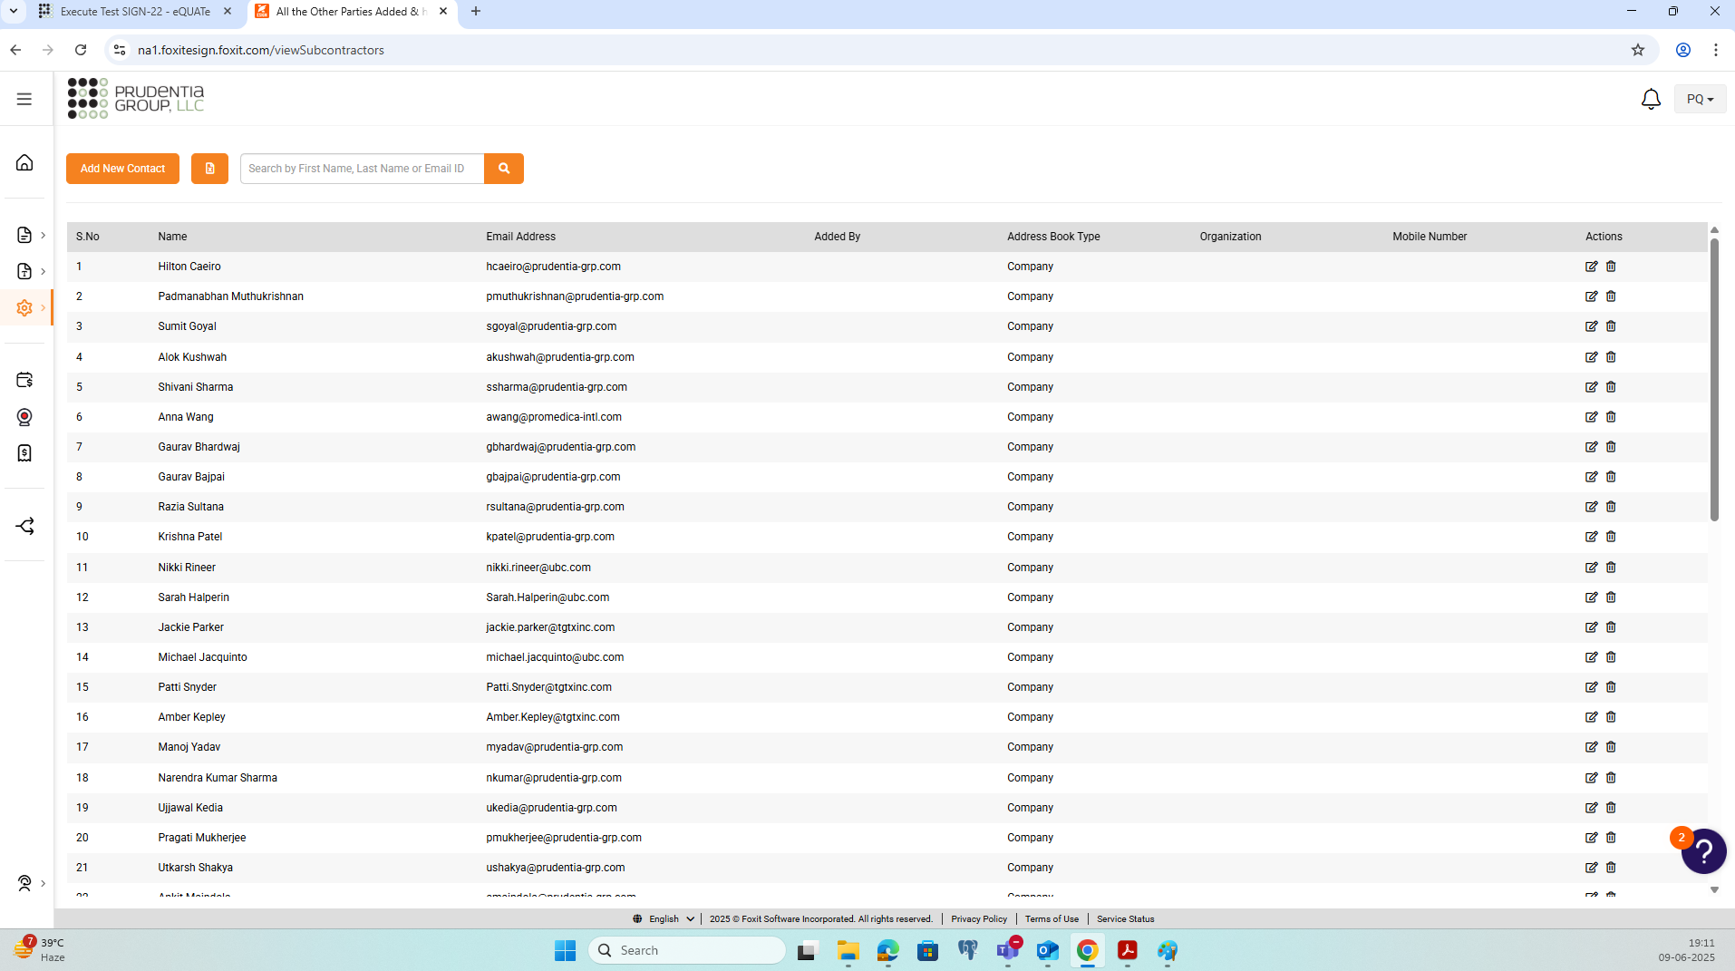

Step No. | Step Description |  | Step Data | Expected Results | Pre-Execution Attachments
46 | Upload <Test Document> to eQMS-Sign.  Navigate to 'Add Signers' screen and add <Contact2> in "Add Recipient/Signer".  Set the following parameters:  - Enforce Signing Sequence: Yes  - Enable In Person Signing: No  - Authentication Level: No Authentication  - <Contact2>: Fill Out Fields and Sign  Navigate to the 'Prepare' screen and add the following fields:  - Section "Document Preparation": Signature Field and Date Signed Field  For "Field Properties" set the following:  Signature Field in "Document Preparation" section  - Signature Field Properties: < Contact2>  Date Signed Field in "Document Preparation" section  - Date Field Properties: <Contact2>  Navigate to the 'Send' screen and send out the document for signatures. |  | NA | The document is sent out for signatures. | NA
Evidence |  | Discrepancy |  | Actual Results | Status
NA |  | NA |  | As expected. | PASS

Step No. | Step Description |  | Step Data | Expected Results | Pre-Execution Attachments
47 | Log out from eQMS-Sign. |  | NA | Tester is logged out from eQMS-Sign. | NA
Evidence |  | Discrepancy |  | Actual Results | Status
NA |  | NA |  | As expected. | PASS

Step No. | Step Description |  | Step Data | Expected Results | Pre-Execution Attachments
48 | Login in to email application for <Contact2> and confirm that a notification has been received from eQMS-Sign.  Attach the email as evidence. |  | NA | Confirmed that a notification has been received by <Contact2>.  Notification email attached as evidence. | NA
Evidence |  | Discrepancy |  | Actual Results | Status
Notification_Step#48.pdf |  | NA |  | As expected. | PASS

Step No. | Step Description |  | Step Data | Expected Results | Pre-Execution Attachments
49 | Click on the link to access the document in the notification email.  On the eQMS-Sign login page, login using account <Contact2>.  Accept the instructions shown by eQMS-Sign till you can view the document to be signed. |  | NA | The document <Test Document> will be displayed. | NA
Evidence |  | Discrepancy |  | Actual Results | Status
NA |  | NA |  | As expected. | PASS

Step No. | Step Description |  | Step Data | Expected Results | Pre-Execution Attachments
50 | Under 'More Actions' click on 'Decline to Sign'.  In the pop-up window add a reason and click on 'Cancel Now'. |  | NA | The tester completes all required actions. | NA
Evidence |  | Discrepancy |  | Actual Results | Status
NA |  | NA |  | As expected. | PASS

Step No. | Step Description |  | Step Data | Expected Results | Pre-Execution Attachments
51 | Log out from eQMS-Sign. |  | NA | Tester is logged out from eQMS-Sign. | NA
Evidence |  | Discrepancy |  | Actual Results | Status
NA |  | NA |  | As expected. | PASS

Step No. | Step Description |  | Step Data | Expected Results | Pre-Execution Attachments
52 | Confirm that <Admin User> has received a notification from eQMS-Sign indicating that the document is voided.  Attach the email as evidence. |  | NA | Confirmed that notification has been received by <Admin User>.  Notification email attached as evidence. | NA
Evidence |  | Discrepancy |  | Actual Results | Status
Notification_Step#52.pdf |  | NA |  | As expected. | PASS

Step No. | Step Description |  | Step Data | Expected Results | Pre-Execution Attachments
53 | Try to login in to eQMS-Sign with user ID for <Contact2> and wrong password five times.  Verify that the user gets a message that the account is locked.  Take screenshots as evidence. |  | NA | Verified that the user gets a message that the account is locked.  Screenshot attached. | NA
Evidence |  | Discrepancy |  | Actual Results | Status
screenshot-27_Step#53.png |  | NA |  | As expected. | PASS

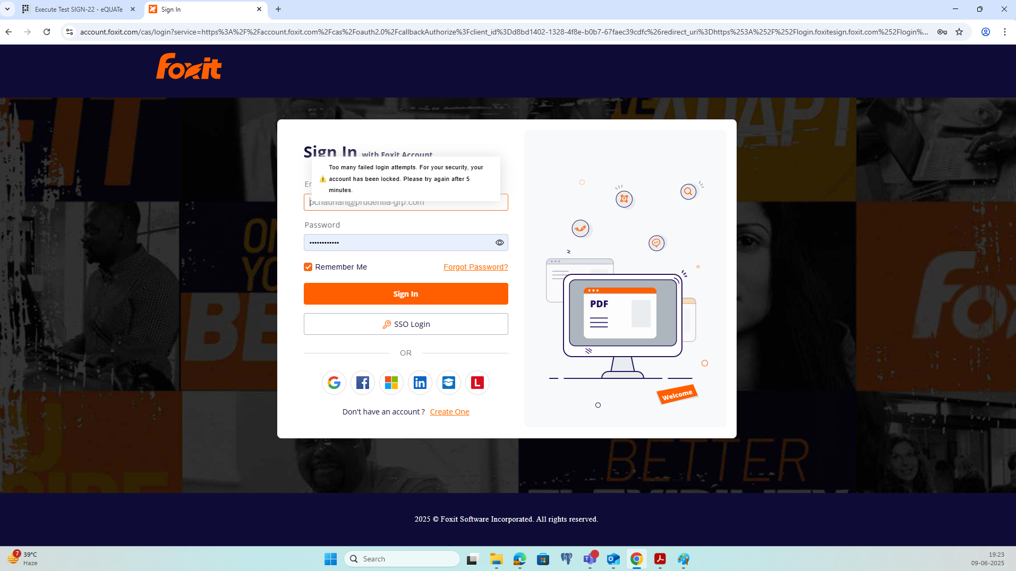

Step No. | Step Description |  | Step Data | Expected Results | Pre-Execution Attachments
54 | After 5 minutes, try to login to eQMS-Sign using the correct credentials for <Contact2>  Take screenshots as evidence. |  | NA | eQMS-Sign home page is displayed.  Screenshot is attached. | NA
Evidence |  | Discrepancy |  | Actual Results | Status
screenshot-28_Step#54.png |  | NA |  | As expected. | PASS

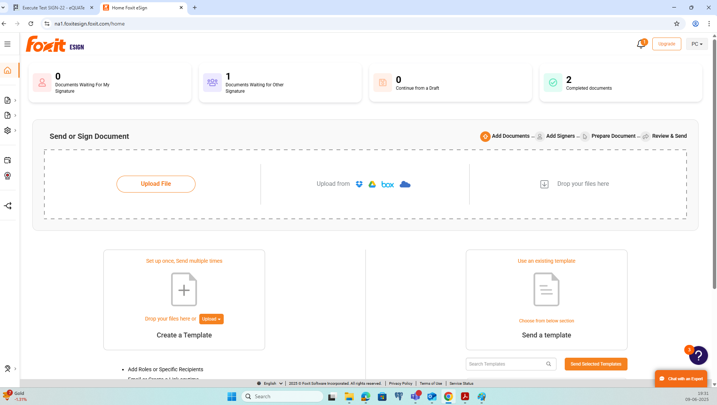

Step No. | Step Description |  | Step Data | Expected Results | Pre-Execution Attachments
55 | Log out from eQMS-Sign. |  | NA | Tester is logged out from eQMS-Sign. | NA
Evidence |  | Discrepancy |  | Actual Results | Status
NA |  | NA |  | As expected. | PASS

- Discrepancy Log
There are no discrepancies for this test execution.

- Post-Execution Approvals (Electronic Signatures)
STATUS: APPROVED
The undersigned acknowledge they have reviewed/approved the Test Execution

Meaning of Signature | Role |  | Signed By |  | Date |  | Comments
TESTER |  | Script Tester |  | Preeti Chauhan (pchauhan) |  | 10-Jun-2025 11:33 AM IST |  | Sending for review
REVIEWER |  | System Owner |  | Hilton Caeiro (HCaeiro) |  | 10-Jun-2025 8:05 AM EDT |  | Reviewed and approved.
APPROVER |  | QA Lead |  | Padmanabhan G M (pmuthukrishnan) |  | 10-Jun-2025 7:30 PM IST |  | Approved.

