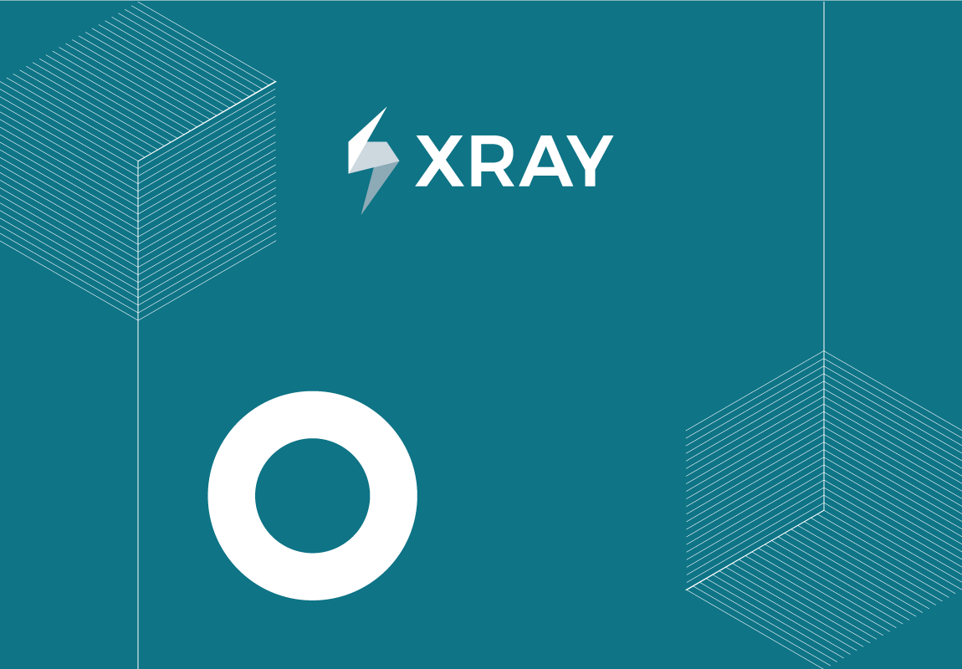

TEST REPORT

&{for issues|filter=%{${BulkIssueIndex} == 0}}

Project Name: ${ProjectName}

Prepared by: ${fullname:Reporter}

CONFIDENTIAL
&{end}

Document Date: %{(new Date()).getDate() + "/" + ((new Date()).getMonth()+1) + "/" + (new Date()).getFullYear()}
TABLE OF CONTENTS
1. Introduction 3
1.1. Document Overview 3
1.2. Total tests 3
1.3. Requirements covered by these Tests 3
2. Tests 5
2.1. @{title=${Key}|href=${BaseURL}/browse/${Key}}: ${Summary} 5
2.1.1. Test Summary 5
2.1.2. Test Description 5
2.1.3. Test Issue Attachments 5
2.1.4. Status of the last execution 6
2.1.5. Requirements 6
2.1.6. Preconditions 7
2.1.7. Test Details 7
2.1.8. Test Sets 9
2.1.9. Test Plans 9
3. Appendix A: Test Report Approval 11

Introduction
${set(supportedImageFormats, ‘gif,jpg,jpeg,png’)}
${set(stepTestTypes, ‘manual’)}
${set(gherkinTestTypes, ‘cucumber,gherkin,behave,behat’)}
${set(unstructuredTestTypes, ‘generic,exploratory’)}
${prop(xporter.document.autofit,true)}

Document Overview
This test report provides a detailed list of tests and their specification. This document has been generated automatically from the test management platform.

Total tests
This is the current distribution of tests by their type.
Test Type | Number of Tests
Manual | ${set(testCount, 0)}  &{for issues}  #{if (%{',${stepTestTypes},'.indexOf(',${TestType},'.toLowerCase()) >= 0})}  ${set(testCount, %{${testCount} + 1})}  #{end}  &{end}  ${testCount}
Gherkin | ${set(testCount, 0)}  &{for issues}  #{if (%{',${gherkinTestTypes},'.indexOf(',${TestType},'.toLowerCase()) >= 0})}  ${set(testCount, %{${testCount} + 1})}  #{end}  &{end}  ${testCount}
Unstructured | ${set(genericTestCount, 0)}  ${set(exploratoryTestCount, 0)}  ${set(otherTestCount, 0)}  &{for issues}  #{if (%{',${unstructuredTestTypes},'.indexOf(',${TestType},'.toLowerCase()) >= 0 && '${TestType}'.equals('Generic')})}  ${set(genericTestCount, %{${genericTestCount} + 1})}  #{end}  #{if (%{',${unstructuredTestTypes},'.indexOf(',${TestType},'.toLowerCase()) >= 0 && '${TestType}'.equals('Exploratory')})}  ${set(exploratoryTestCount, %{${exploratoryTestCount} + 1})}  #{end}  #{if (%{',${unstructuredTestTypes},'.indexOf(',${TestType},'.toLowerCase()) >= 0 && !'${TestType}'.equals('Generic') && !'${TestType}'.equals('Exploratory')})}  ${set(otherTestCount, %{${otherTestCount} + 1})}  #{end}  #{end}  &{end}  Generic: ${genericTestCount}  Exploratory: ${exploratoryTestCount}  Other: ${otherTestCount}

Requirements covered by these Tests
${set(count, 0)}
&{for issues}
#{for j=LinksCount|filter=%{'${Links[j].LinkType}'.equals('tests')}}
${set(count,%{${count}+1})}
#{end}
&{end}
#{if (%{${count} == 0})}
None
#{end}
#{if (%{${count} > 0})}
Key | Summary | Version | Workflow Status
&{for issues}
#{for j=LinksCount|filter=%{'${Links[j].LinkType}'.equals('tests')}}
#{if (%{'${UniqueReqsList}'.indexOf('[${Links[j].Key}]')==-1})}
${set(UniqueReqsList,%{'${UniqueReqsList}'.concat('[${Links[j].Key}]')})}
@{title=${Links[j].Key}|href=${BaseURL}/browse/${Links[j].Key}} | ${Links[j].Summary} | ${Links[j].FixVersions} | ${Links[j].Status}
#{end}
#{end}
&{end}
#{end}

Tests
&{for issues|filter=%{'${IssueTypeName}'.equals('Test')}}

@{title=${Key}|href=${BaseURL}/browse/${Key}}: ${Summary}

Test Summary
The purpose of this test is: ${Summary}.

Test Type | Label(s) | Component(s) | Priority
${TestType} | ${Labels} | ${Components} | ${Priority}

Test Description
#{if (%{'${Description}'.equals('')})}
None
#{end}
#{if (%{!'${Description}'.equals('')})}
${wiki:Description}
#{end}

Test Issue Attachments
#{if (%{'${AttachmentsCount}'.equals('0')})}
This test has ${AttachmentsCount} attachments.
#{end}
#{if (%{'${AttachmentsCount}'>0})}
File Name | Author | File Size (bytes)
#{for b=AttachmentsCount}
${set(extension,%{ var tmpArray='${Attachments[b].Name}'.split('.'); tmpArray[tmpArray.length - 1].toLowerCase()})}
#{if (%{',${supportedImageFormats},'.indexOf(',${extension},') == -1})}
@{title=${Attachments[b].Name}|href=${Attachments[b].FileURL}} | ${fullname:Attachments[b].Author} | ${Attachments[b].Size}
#{end}
#{end}
#{end}
#{if (%{'${ImagesCount}'>0})}
#{for b=ImagesCount}
@{title=${Images[b].Name}|href=${Images[b]. ThumbnailURL}}  !{${Images[b].ThumbnailURL}|width=100} | ${fullname:Images[b].Author} | ${Images[b].Size}
#{end}
#{end}

Status of the last execution
#{if (%{'${TestStatus}'.equals('FAILED')})}
${TestStatus}
#{end}
#{if (%{'${TestStatus}'.equals('PASSED')})}
${TestStatus}
#{end}
#{if (%{'${TestStatus}'.equals('TO DO')})}
${TestStatus}
#{end}
#{if (%{'${TestStatus}'.equals('EXECUTING')})}
${TestStatus}
#{end}
#{if (%{'${TestStatus}'.equals('ABORTED')})}
${TestStatus}
#{end}

Requirements
${set(count, 0)}
#{for j=LinksCount|filter=%{'${Links[j].LinkType}'.equals('tests')}}
${set(count,%{${count}+1})}
#{end}
#{if (%{${count} == 0})}
None
#{end}
#{if (%{${count} > 0})}
Key | Summary | Version | Workflow Status
#{for j=LinksCount|filter=%{'${Links[j].LinkType}'.equals('tests')}}
@{title=${Links[j].Key}|href=${BaseURL}/browse/${Links[j].Key}} | ${Links[j].Summary} | ${Links[j].FixVersions} | ${Links[j].Status}
#{end}
#{end}

Preconditions
#{if (%{'${PreConditionsCount}'.equals('0')})}
None
#{end}
#{if (%{!'${PreConditionsCount}'.equals('0')})}
Key | Summary | Condition
#{for preconditions}
@{title=${PreConditions[n].Key}|href=${BaseURL}/browse/${PreConditions[n].Key}} | ${PreConditions[n].Summary} | ${PreConditions[n].PreCondition.Definition}
#{end}
#{end}

Test Details
#{if (%{',${stepTestTypes},'.indexOf(',${TestType},'.toLowerCase()) >= 0})}
This ${TestType} test has ${TestStepsCount} steps.

Step | Action | Data | Expected Result | Attachments
#{for m=TestStepsCount}
#{if (%{!${TestSteps[m].IsCalledTest}})}
${TestSteps[m].StepNumber} | ${wiki:TestSteps[m].Action} | ${wiki:TestSteps[m].Data} | ${wiki:TestSteps[m].ExpectedResult} | #{for sa=TestSteps[m].AttachmentsCount}  @{title=${TestSteps[m].Attachments[sa].Name}|href=${TestSteps[m].Attachments[sa].FileURL}}  !{${TestSteps[m].Attachments[sa].Attachment}|maxwidth=100}  #{end}
#{end}
#{if (%{${TestSteps[m].IsCalledTest}})}
called Test ${TestSteps[m].CalledTest.Key}: ${TestSteps[m].CalledTest.Summary}
#{if (%{${TestSteps[m].CalledTestParametersCount}>0})}
Parameter | Value
#{for p=TestSteps[m].CalledTestParametersCount}
${TestSteps[m].CalledTestParameters[p].Name} | ${TestSteps[m].CalledTestParameters[p].Value}
#{end}
#{end}

#{for y=TestSteps[m].CalledTest.TestStepsCount}
#{if (%{!${TestSteps[m].CalledTest.TestSteps[y].IsCalledTest}})}
${TestSteps[m].StepNumber}. ${TestSteps[m].CalledTest.TestSteps[y].StepNumber} | ${wiki:TestSteps[m].CalledTest.TestSteps[y].Action} | ${wiki:TestSteps[m].CalledTest.TestSteps[y].Data} | ${wiki:TestSteps[m].CalledTest.TestSteps[y].ExpectedResult} | #{for sa=TestSteps[m].CalledTest.TestSteps[y].AttachmentsCount}  @{title=${TestSteps[m].CalledTest.TestSteps[y].Attachments[sa].Name}|href=${TestSteps[m].CalledTest.TestSteps[y].Attachments[sa].FileURL}}  !{${TestSteps[m].CalledTest.TestSteps[y].Attachments[sa].Attachment}|maxwidth=100}  #{end}
#{end}
#{if (%{${TestSteps[m].CalledTest.TestSteps[y].IsCalledTest}})}
called Test ${TestSteps[m].CalledTest.TestSteps[y].CalledTest.Key}: ${TestSteps[m].CalledTest.TestSteps[y].CalledTest.Summary}
#{end}
#{end}
#{end}
#{end}
#{end}

#{if (%{',${gherkinTestTypes},'.indexOf(',${TestType},'.toLowerCase()) >= 0})}
Test Type | ${TestType}
Gherkin Specification | ${Cucumber Scenario}
#{end}
#{if (%{',${unstructuredTestTypes},'.indexOf(',${TestType},'.toLowerCase()) >= 0})}
Test Type | ${TestType}
Specification | ${Generic Test Definition}
#{end}

Test Sets
#{if (%{${TestSetsCount} === 0})}
None
#{end}
#{if (%{${TestSetsCount} > 0})}
Key | Summary | Version
#{for x=TestSetsCount}
@{title=${TestSets[x].Key}|href=${BaseURL}/browse/${TestSets[x].Key}} | ${TestSets[x].Summary} | ${TestSets[x].FixVersions}
#{end}
#{end}

Test Plans
#{if (%{${TestPlansCount} === 0})}
None
#{end}
#{if (%{${TestPlansCount} > 0})}
Key | Summary | Version
#{for x=TestPlansCount}
@{title=${TestPlans[x].Key}|href=${BaseURL}/browse/${TestPlans[x].Key}} | ${TestPlans[x].Summary} | ${TestPlans[x].FixVersions}
#{end}
#{end}
&{end}
&{end}

Appendix A: Test Report Approval
The undersigned acknowledge they have reviewed the Test Report and agree with the approach it presents. Changes to this Test Report will be coordinated with and approved by the undersigned or their designated representatives.

Signature: |  | Date:
Print Name:
Title:
Role:

