

TEST REPORT

Project Name: Xray Sample Project - Online Store (15)

Prepared by:

CONFIDENTIAL

Document Date: 1/4/2026
TABLE OF CONTENTS
1. Introduction 3
1.1. Document Overview 3
1.2. Total tests 3
1.3. Requirements covered by these Tests 3
2. Tests 4
2.1. XSP15-3429: SCH518.1-Intermarket Store to Store Consignment Transfer RF to RF (SG to AU) - Multi SKU, Multi QTY 4
2.1.1. Test Summary 4
2.1.2. Test Description 4
2.1.3. Test Issue Attachments 4
2.1.4. Status of the last execution 4
2.1.5. Requirements 4
2.1.6. Preconditions 4
2.1.7. Test Details 4
2.1.8. Test Sets 8
2.1.9. Test Plans 8
3. Appendix A: Test Report Approval 9

Introduction

Document Overview
This test report provides a detailed list of tests and their specification. This document has been generated automatically from the test management platform.

Total tests
This is the current distribution of tests by their type.
Test Type | Number of Tests
Manual | 1
Gherkin | 0
Unstructured | Generic: 0  Exploratory: 0  Other: 0

Requirements covered by these Tests
None

Tests

XSP15-3429: SCH518.1-Intermarket Store to Store Consignment Transfer RF to RF (SG to AU) - Multi SKU, Multi QTY

Test Summary
The purpose of this test is: SCH518.1-Intermarket Store to Store Consignment Transfer RF to RF (SG to AU) - Multi SKU, Multi QTY.

Test Type | Label(s) | Component(s) | Priority
Manual |  |  | Medium

Test Description
None

Test Issue Attachments
This test has 0 attachments.

Status of the last execution
TO DO

Requirements
None

Preconditions
None

Test Details
This Manual test has 2 steps.

Step | Action | Data | Expected Result | Attachments
1 | 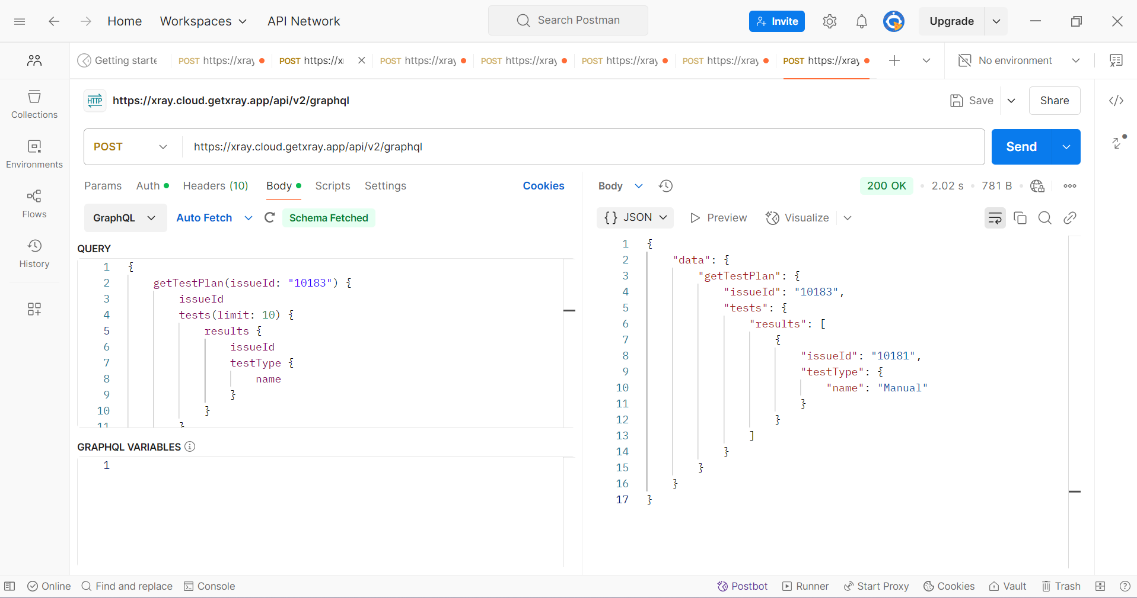 |  |  | Screenshot 2025-03-26 080647.png  !{|maxwidth=100}
2 | 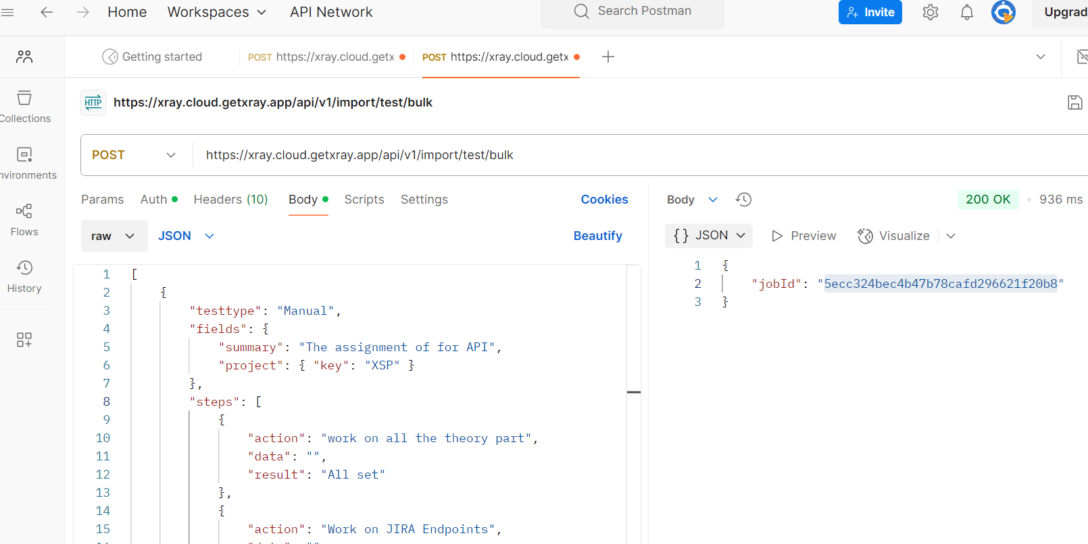 | 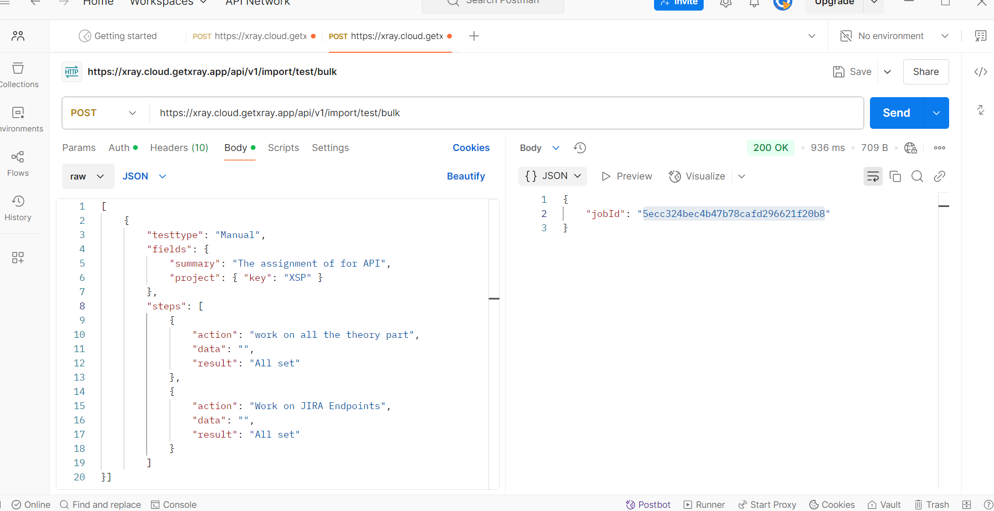 |  | Screenshot 2025-03-26 053817.png  !{|maxwidth=100}  Screenshot 2025-03-26 053835.png  !{|maxwidth=100}

Test Sets
None

Test Plans
None

Appendix A: Test Report Approval
The undersigned acknowledge they have reviewed the Test Report and agree with the approach it presents. Changes to this Test Report will be coordinated with and approved by the undersigned or their designated representatives.

Signature: |  | Date:
Print Name:
Title:
Role:

